FY 22 Streamlined Balance Sheet Modifications: Other Assets/Other Liabilities
Effective FY 22 Reporting
1) USSGL 199000F “Other Assets” (Federal)
- Moving From Line 3.4 Accounts receivable, net (RC 22)
- To New Line 6.3 Other assets – Reimbursable activities (RC 22)

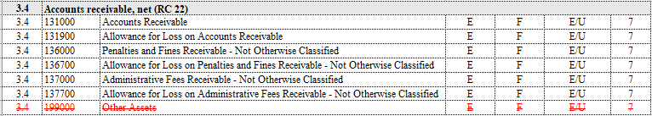

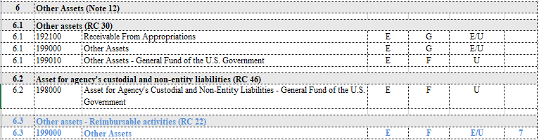

2) USSGL 219000F “Other Liabilities With Related Budgetary Obligations” (Federal)
- Moving From Line 22.2 Accounts payable (RC 22)
- To New Line 26.6 Other liabilities - Reimbursable activities (RC 22)

3) USSGL 299000F “Other Liabilities Without Related Budgetary Obligations” (Federal)
- Moving From Line 22.2 Accounts payable (RC 22)
- To New Line 26.6 Other liabilities - Reimbursable activities (RC 22)

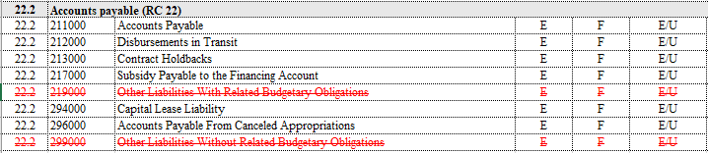

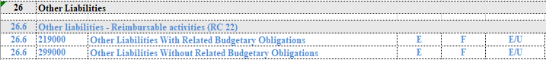

FY 23 Streamlined Balance Sheet Modifications: Interest Receivable/Payable
Effective FY 23 Reporting
1) USSGL 134000F “Interest Receivable – Not Otherwise Classified” (Federal)
- Moving From Line 4.1 Interest receivable, loans and not otherwise classified (RC 04)
- To Line 3.4 Accounts receivable, net (RC 22)

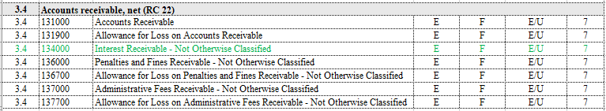

2) USSGL 214000F “Accrued Interest Payable – Not Otherwise Classified” (Federal)
- Moving From Line 24.1 Interest payable – loans and not otherwise classified (RC 04)
- To Line 22.2 Accounts payable (RC 22)

