Proposed USSGL Board Member Survey

What’s your take? - We want Governmentwide input on a variety of topics. Please ensure that you circulate any feedback through your USSGL Board Member.

The U.S. Standard General Ledger - Contact Us - USSGL Board Agency Contacts (treasury.gov)

Timeline:

April 18th IRC – Present draft versions of questions.

April 18th through April 26th – Gather feedback on additional questions.

May 1st – Present the Survey at USSGL Board Meeting.

May 1st – Distribute survey monkey link to USSGL Board Members.

May 15th – Deadline to complete survey.

After May 15th – Follow up on survey responses.

Proposed Questions:

- Are there existing TFM Sections that you’d like to see in a different file format to facilitate agency accounting systems or other needs? (i.e. Excel, Access, web-based)

- Are there current TFM Sections that your agency does not use/does not find useful?

- Is there USSGL, Financial Statement, or GTAS data on which your agency depends, but is not currently available in the USSGL TFM Supplement, or your agency must manually adjust to fit its needs?

- Do you have any concerns with the display and/or usefulness of the USSGL TFM Supplement website?

- Do you feel the combined file within the TFM supplement is useful?

Part 1 Fiscal Year 2024 Reporting | TFX: Treasury Financial Experience

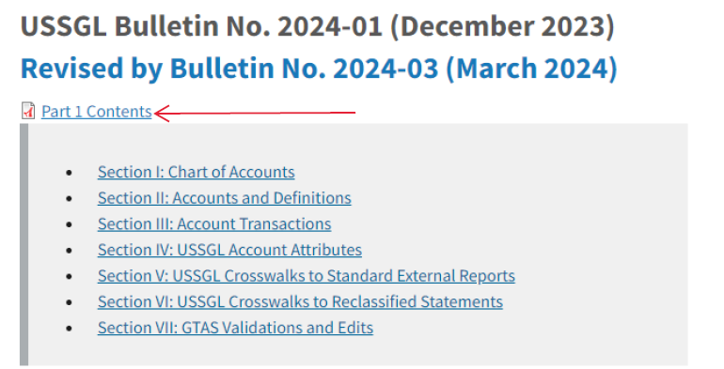

- Do you feel the Transactions Listing within Section III of the TFM is useful?

Part 1 Fiscal Year 2024 Reporting | TFX: Treasury Financial Experience

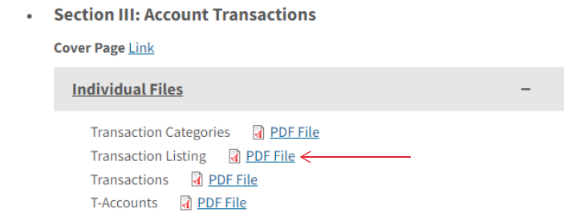

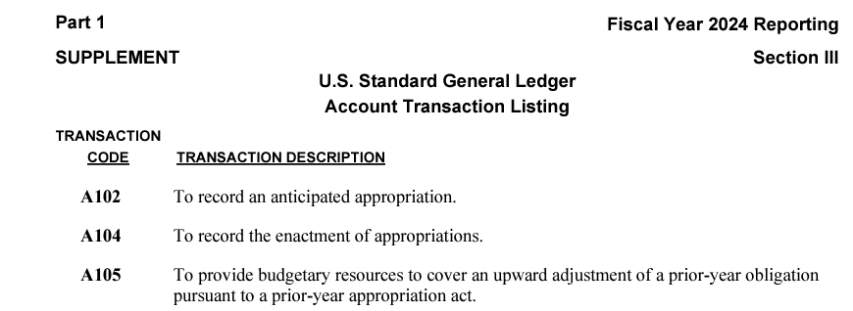

- Please feel free to suggest additional questions for the survey through your USSGL Board representative and send to USSGLteam@fiscal.treasury.gov.

