Attention! Attention!
Governmentwide Treasury Account Symbol Adjusted Trial Balance System (GTAS) Edits 125-132 Going Fatal!!

GTAS Edits 125-132 will go fatal in fiscal year (FY) 2025 for the November GTAS Reporting Window.

Who is impacted?
There are currently only 20 federal entities that have Credit Reform appropriations where GTAS Edits 125-132 would apply.

How do I know if my entity has a Credit Reform appropriation?
Federal Entities can inquire with Office of Management and Budget’s (OMB) Credit Crew by emailing creditcrew@omg.eop.gov. Before doing so, federal entities can check the Federal Credit Supplement at https://www.whitehouse.gov. Tables 1 and 2 display programs expected to make new loans in FY 2024 and FY2025, and Tables 7 and 8 show programs that have ever made loans in previous fiscal years.

How do you fail an edit?
When a federal entity only reports the United States Standard General Ledger (USSGL) and the corresponding Business Event Type Code (BETC) is not used in the Central Accounting Reporting System (CARS), a balance will show on the USSGL side of the edit but not the BETC side and trigger failure. Additionally, when a federal entity reports one of the credit reform BETCs in CARS, but the corresponding USSGL is not reported to GTAS, a balance will show on the BETC side of the edit but not the USSGL side and trigger failure.

Can my entity fail the edit without having a Credit Reform appropriation?
Yes. If any federal entity reports one of the USSGLs or BETCs in Edits 125-132, they will trigger that the applicable edit and potentially fail (if the USSGL or BETC are used incorrectly).

Which BETCs are part of GTAS Edits 125 – 132?
Please see the GTAS Edit Detail Reports below

Where can my entity find the edit details?
The link to Treasury’s GTAS Edits Detail Report has been provided below:
https://tfx.treasury.gov/tfm/supplements/ussgl/ussgl-part-1
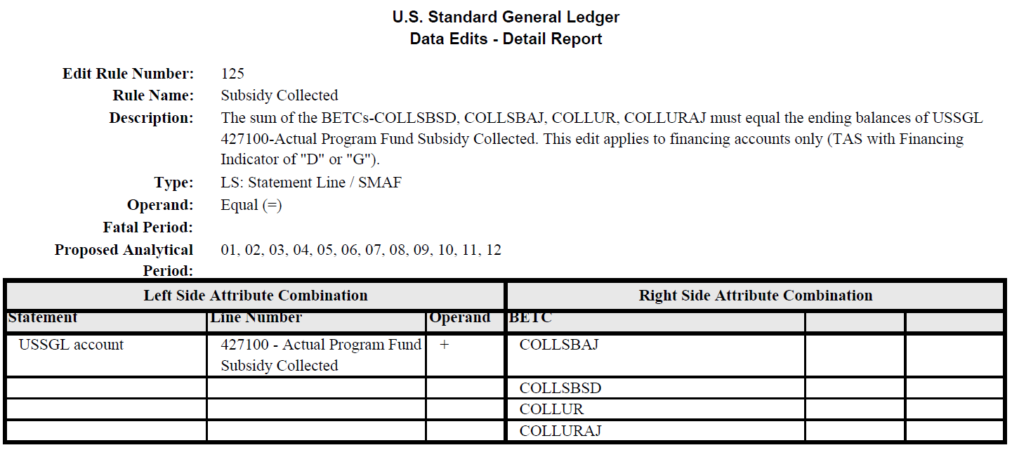

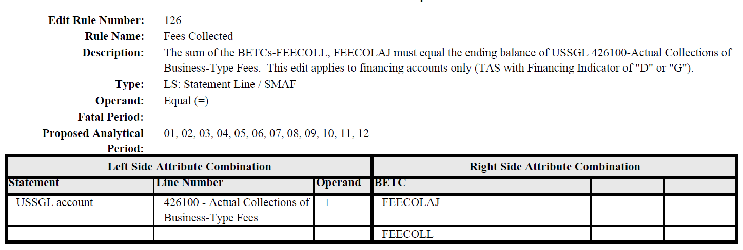

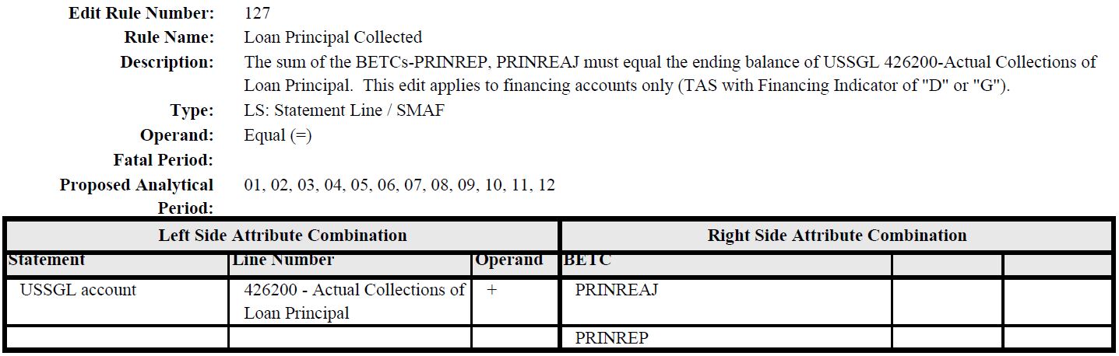

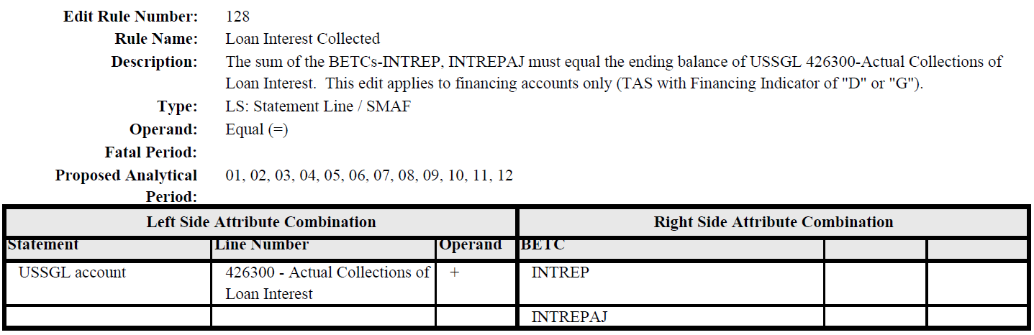

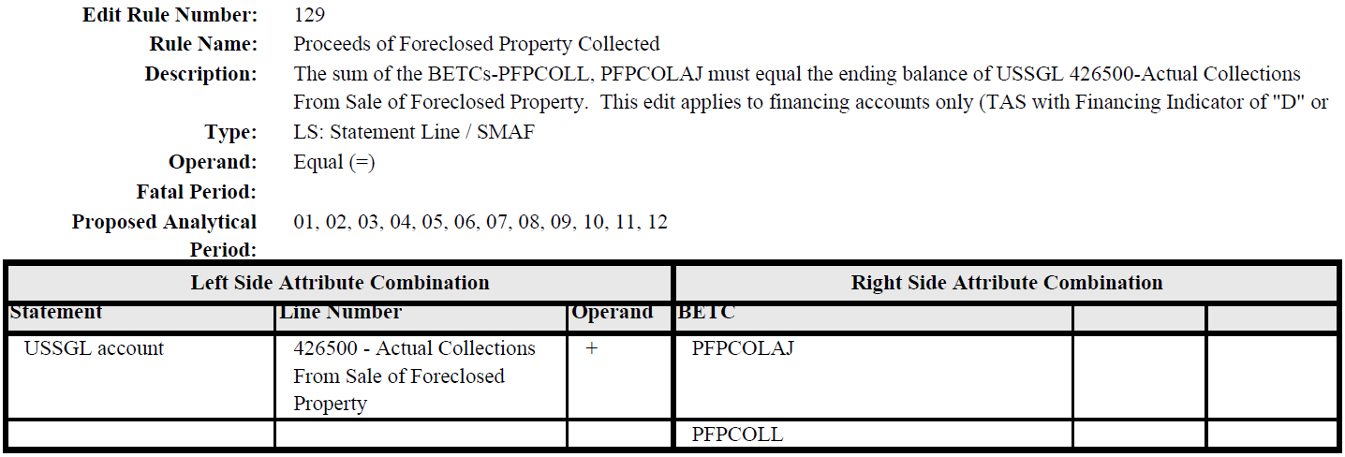

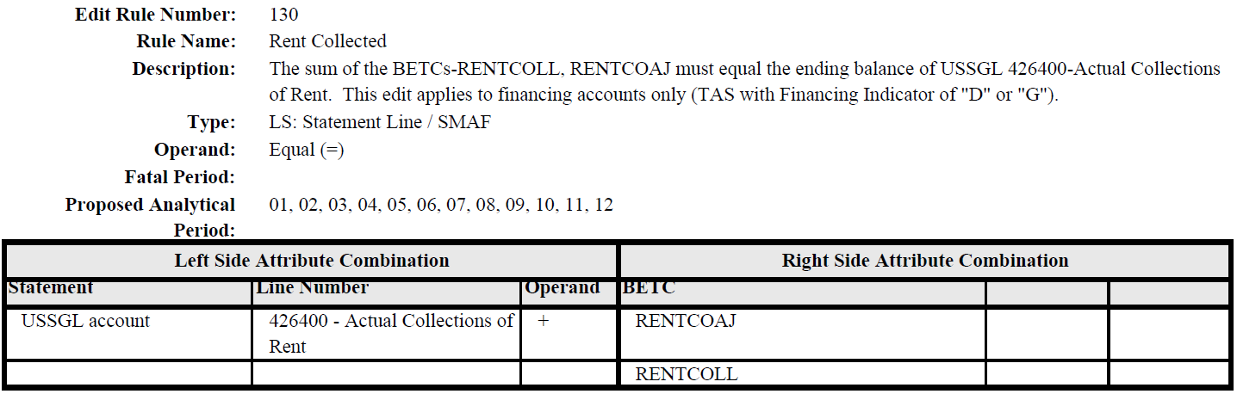

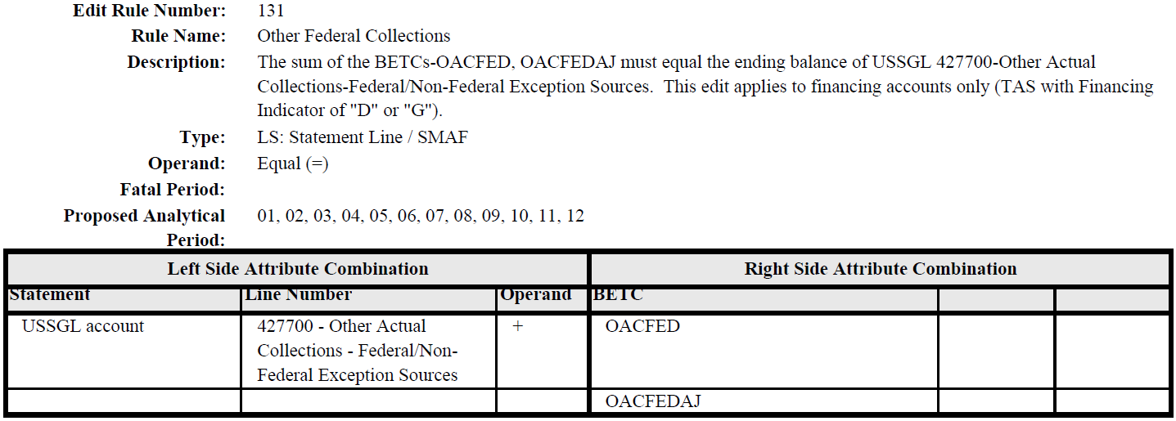

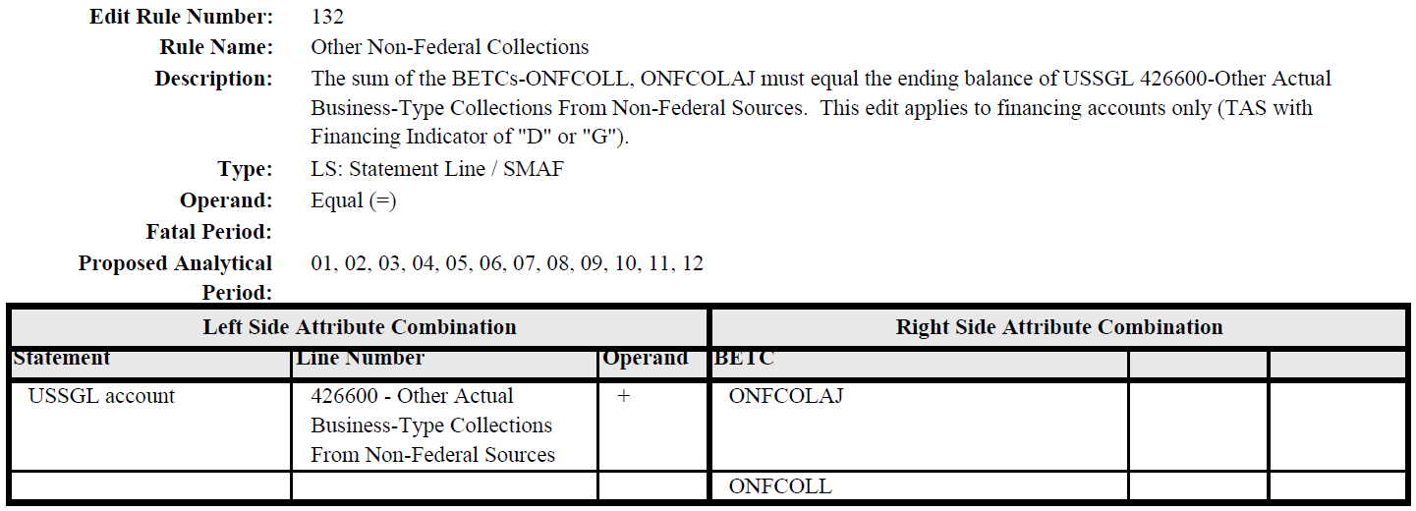

Who do I contact with additional questions?
The General Fund will answer any questions regarding GTAS Edits 125 – 132 going fatal. Please send an email to GeneralFund@fiscal.treasury.gov with details.

How does my entity know if we are passing or failing an edit?
Federal entities can access GTAS and go to Bulk File, then My ATB Status, and click on Failed Edits. You can select “More Info on a TAS” which will show entities which GTAS Edits they failed for that TAS (and more detail around why they failed). A report can also be run out of GTAS by clicking on Reports, then selecting the Validations/Edits link to show which GTAS edits their entity failed.

The General Fund also does a quarterly analysis to determine which entities and TAS are passing or failing Edits 125 – 132. Please email the General Fund inbox, requesting your entity’s data.

The General Fund looks forward to assisting your entity with passing GTAS Edits 125 -132 throughout FY 2024 in preparation for when the GTAS Edits go fatal for Period 2 FY 2025 reporting.

Thank you for your engagement, commitment, and compliance with these requirements! Please submit questions to GeneralFund@fiscal.treasury.gov.

