New and Revised Budgetary USSGL Accounts

FY 25 Proposed Additions:
Account Title: Contract Authority To Be Liquidated by Trust Funds - FMSTF
Account Number: 413610
Normal Balance: Credit
Definition: This account is used to record the amount of funds received during the fiscal year from appropriations derived from trust fund receipts that will liquidate contract authority. This account does not close at year-end. This account is recorded for FMS case funds that are under control of the U.S. Government in the Federal Reserve or Commercial Banks but have not been deposited at Treasury.

Justification: Added because FMSTF needs an account similar to USSGL account 413600, specific for their own activity. This account is only applicable to one specific DOD account.

U S S G L A C C O U N T |  | USSGL ATTRIBUTES |  |  | B U L K F I L E A T T R I B U T E S |  |  |  |  |  |  | T A S A T T R I B U T E S
USSGL Acct. | USSGL Account Title | Anti-ci-pated | Budg/ Prop | Norm Bal | Begin/ End | Debit/ Credit | Auth Type Code | BEA Cat | PY  Adj | DEFC | Reimb Flag | Fund Type | Reporting Type Code | Financing Account Code | TAS Status | Trans. Code
413610 | Contract Authority To Be Liquidated by Trust Funds FMSTF | N | B | C | B/E | D/C | P | M | B/X | 1 or 3 character OMB approved value | D | ET | E/F/U | N | U | N

Affected TCs: A230 & A231 (See Budgetary TC Additions and Revisions handout for details)

FY25 Proposed Revisions:
Account Title: Contract Authority Liquidated
Account Number: 413500
Normal Balance: Credit
Definition: This account is used to record the amount of funds received during the fiscal year from appropriations, non-expenditure
transfers, or offsetting collections that liquidate contract authority. For the Foreign Military Sales Trust Fund, this account is
recorded when collections made to FMS cases are received at Treasury.

Justification: Updating to add specific verbiage for FMSTF. This update relates to new USSGL account 413610.

Account Title: Allocations of Authority – Anticipated Transfers From Invested Balances - Prior Year
Account Number: 416512
Normal Balance: Debit
Definition: The amount of prior year budget authority anticipated by a receiving allocation Treasury Appropriation Fund Symbol
(TAFS), based on an apportionment request by the receiving TAFS, to be distributed from the parent TAFS via non-expenditure
transfer, during the fiscal year. Use this USSGL account in conjunction with USSGL accounts 416612, "Allocations of Realized
Authority - To Be Transferred From Invested Balances - Prior Year," and/or 416712, "Allocations of Realized Authority – Transferred
From Invested Balances - Prior Year."

Justification: Revising the title to align with USSGL Account 416500.

FY 26 Proposed Additions:

Account Title: Appropriated Debt - Derived From Unavailable Special Fund Receipts
Account Number: 411330
Normal Balance: Debit
Definition: This account is used to record appropriations derived from unavailable special fund receipts and used for capital
investments that are required to be repaid but are not considered lending by the U.S. Treasury. This account is used to record the
amount of receipts appropriated from an "unavailable" special fund receipt account to a corresponding special fund expenditure
account. (Amounts deposited into special fund receipt accounts designated by the Department of the Treasury as "unavailable" are
appropriated via Treasury warrant, upon legislative action, to the corresponding expenditure account). This budgetary resource
account does not correspond with proprietary USSGL account 310100, "Unexpended Appropriations - Appropriations Received."

Justification: This account will provide a needed mechanism for proper budgetary reporting of Appropriated Debt. These are only
applicable to specific DOE accounts.

Affected TC: A238 (See Budgetary TC Additions and Revisions handout for details)

Account Title: Appropriated Debt – Derived From the General Fund of the U.S. Government
Account Number: 411930
Normal Balance: Debit
Definition: This account is used to record appropriations derived from the General Fund of the U.S. Government and used for capital
investments that are required to be repaid but are not considered lending by the U.S. Treasury.

Justification: This account will provide a needed mechanism for proper budgetary reporting of Appropriated Debt. These are only
applicable to specific DOE accounts.

Affected TCs: A236 (See Budgetary TC Additions and Revisions handout for details)

Account Title: Transfer of Unpaid Obligations and Uncollected Customer Payments
Account Number: 419400
Normal Balance: Debit
Definition: This account is used to record the amount of unpaid obligations and uncollected customer payments from federal sources
of equal amounts via non-expenditure transfer during the fiscal year. Fund Balance With Treasury is not impacted with the use of this
account. Although the normal balance for this account is debit, it is acceptable for this account to have a credit balance.

Justification: This is needed to transfer unpaid obligation and uncollected customer payments that do not impact Fund Balance With Treasury.
Affected TCs: A222, A223, A544, A545, A546, A547, A549, and A551 (See Budgetary TC Additions and Revisions handout for details)

Account Title: Unfilled Customer Orders Without Advance – Transferred – With Offset
Account Number: 423010
Normal Balance: Debit
Definition: This account is used to record the amount in USSGL account 422100, "Unfilled Customer Orders Without Advance,"
transferred from one Treasury Appropriation Fund Symbol to another; and where the account is offset by an unpaid obligation.
Although the normal balance for this account is debit, it is acceptable for this account to have a credit balance.
Justification: This account will provide a mechanism to separate “Unfilled Customer Orders Without Advance – Transferred,” from
those offset by an unpaid obligation and those not offset by an unpaid obligation.

Affected TCs: A544, A545, A546, A547, and F380, (See Budgetary TC Additions and Revisions handout for details)

Account Title: Reimbursements Earned - Receivable – Transferred – With Offset
Account Number: 423310
Normal Balance: Debit
Definition: This account is used to record the amount in USSGL account 425100, "Reimbursements Earned - Receivable," transferred from one Treasury Appropriation Fund Symbol to another; and where the amount is offset by an unpaid obligation. Although the normal balance for this account is debit, it is acceptable for this account to have a credit balance.

Justification: This account will provide a mechanism to separate “Reimbursements Earned – Receivable -Transferred,” from those
offset by an unpaid obligation and those not offset by an unpaid obligation.

Affected TCs: A547, A549, A551, & F386 (See Budgetary TC Additions and Revisions handout for details)

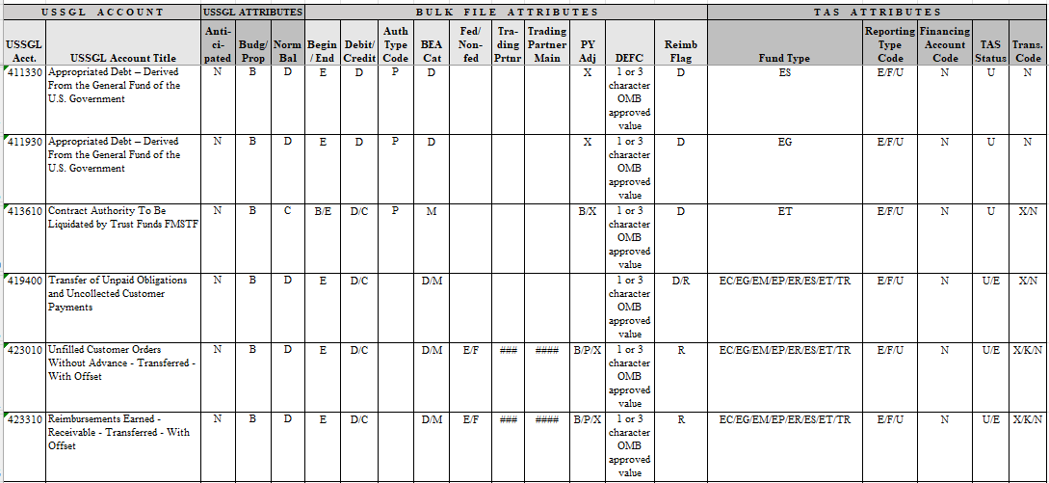

USSGL  Account | Balance  Sheet | Net  Cost | Net  Position | Custodial  Activity | Reclassified  Net Cost | RSCNP | SF133 | Schedule P | SBR
413610  (FY 25) | N/A | N/A | N/A | N/A | N/A | N/A | 1020 & 1238 | 1020 & 1238 | 1071 & 1290
411330  (FY 26) | N/A | N/A | N/A | N/A | N/A | N/A | 1101 | 1101 | 1290
411930  (FY 26) | N/A | N/A | N/A | N/A | N/A | N/A | 1100 | 1100 | 1290
419400  (FY 26) | N/A | N/A | N/A | N/A | N/A | N/A | N/A | N/A | N/A
423010  (FY 26) | N/A | N/A | N/A | N/A | N/A | N/A | 3061, 3080, 3081, 3090, 5342, 5343, & 5344 | 3061, 3080, 3081, 3090, 5342, 5343, & 5344  N/A | N/A
423310  (FY 26) | N/A | N/A | N/A | N/A | N/A | N/A | 3061, 3080, 3081, 3090, 5342, 5343, & 5344 | 3061, 3080, 3081, 3090, 5342, 5343, & 5344 | N/A

FY 26 Proposed Revisions:

Account Title: Unfilled Customer Orders Without Advance – Transferred – No Offset
Account Number: 423000
Normal Balance: Debit
Definition: This account is used to record the amount in USSGL account 422100, "Unfilled Customer Orders Without Advance,"
transferred from one Treasury Appropriation Fund Symbol to another; and where the account is not offset by an unpaid obligation
and remains as an unobligated balance. Although the normal balance for this account is debit, it is acceptable for this account to
have a credit balance.

Justification: Revised due to the addition of USSGL account 423010 to specify that this account is not offset by an unpaid obligation and remains an unobligated balance.

Account Title: Appropriation Trust Fund Expenditure Transfers - Receivable - Transferred
Account Number: 423200
Normal Balance: Debit
Definition: This account is used to record the amount in USSGL account 422500, "Appropriation Trust Fund Expenditure Transfers –
Receivable," transferred from one Treasury Appropriation Fund Symbol to another. Only use USSGL account 423200 when there is
not an unpaid obligation recorded against it as an offset. Although the normal balance for this account is debit, it is acceptable for
this account to have a credit balance.

Justification: Revised to specify that this account is to be used when there is not an unpaid obligation recorded against USSGL
account 423200 as an offset.

Account Title: Reimbursements Earned - Receivable – Transferred – No Offset
Account Number: 423300
Normal Balance: Debit
Definition: This account is used to record the amount in USSGL account 425100, "Reimbursements Earned – Receivable,"
Transferred from one Treasury Appropriation Fund Symbol to another; and where the account is not offset by an unpaid obligation
and remains as an unobligated balance. Although the normal balance for this account is debit, it is acceptable for this account to
have a credit balance.

Justification: Revised to specify that this account is to be used when there is not an unpaid obligation recorded against USSGL
account 423300 as an offset.

Account Title: Other Federal Receivables – Transferred
Account Number: 423400
Normal Balance: Debit
Definition: This account is used to record the amount in USSGL account 428700, "Other Federal Receivables," transferred from one Treasury Appropriation Fund Symbol to another. Only use USSGL account 423400 when there is not an unpaid obligation recorded against it as an offset. Although the normal balance for this account is debit, it is acceptable for this account to have a credit balance.
Justification: Revised to specify that this account is to be used when there is not an unpaid obligation recorded against USSGL account 423400 as an offset.

Account Title: Uncollected Subsidy from Program Account - Transferred
Account Number: 423500
Normal Balance: Debit
Definition: This account is used to record the amount in USSGL account 422300, " UncollectedSubsidy from Program Account,”
transferred from one Treasury Appropriation Fund Symbol (TAFS) to another. Only use USSGL account 423500 when there is not
an unpaid obligation recorded against it as an offset. Although the normal balance for this account is debit, it is acceptable for this
account to have a credit balance.

Justification: Revised to specify that this account is to be used when there is not an unpaid obligation recorded against USSGL
account 423500 as an offset.

FY 26 Proposed Deletions:

Account Title: Appropriation Purpose Fulfilled - Balance Not Available
Account Number: 436000
Normal Balance: Credit
Definition: This account is used to record the portion of the unobligated balances in a no-year Treasury account where the amount is no longer available for obligation since the purposes for which the appropriation was enacted has been carried out. This account does not close at the end of the year.
Justification: Any unobligated balances from budgetary resources classified as direct must be returned to the General Fund of the U.S. Treasury pursuant to U.S.C. 1552 and 1555 and is reported on SF 133/Sch P line 1029 using USSGL accounts 435000 or 435100 effective Fiscal Year 2026. Therefore, USSGL account 436000 is no longer needed.

Affected TCs: F147 (See Budgetary TC Additions and Revisions handout for details)

Account Title: Anticipated Receipts Unavailable for Obligation Upon Collection
Account Number: 439403
Normal Balance: Credit
Definition: This account is used to record the anticipated receipts that, immediately upon collection, are not available for obligation but for investment.

Justification: Effective Fiscal Year 2026, the requirement to incorporate “or only available for investment in Federal Securities” from SF 133 lines 1154/1254 is eliminated. Therefore, USSGL account 439403 is no longer needed.

Affected TCs: A122, A211, F112 (See Budgetary TC Additions and Revisions handout for details)

