Profile of the Economy
(Office of Macroeconomic Analysis)
August 27, 2024
Introduction
Real GDP growth accelerated in the second quarter of 2024 as a resilient labor market continued to support private demand. Labor market strength persisted in the form of real earnings growth as well as an improved labor supply and demand balance—though the pace of job creation moderated, and the unemployment rate steadily increased. Nonetheless, initial unemployment claims remain near historically low levels.

In addition to strong economic growth and persistent labor market strength, the second quarter saw renewed progress in reducing both headline and core inflation—though elevated price levels continue to cool moods among businesses, builders, and consumers. Even so, measures of inflation are now within reasonable range of the Federal Reserve’s target rate as cooling price growth for non-housing services has helped slow core inflation.

Economic Growth
Real GDP growth accelerated to 3.0 percent at an annual rate in the second quarter of this year, according to the second estimate, more than double the first quarter’s 1.4 percent pace. Faster growth largely reflected a pick-up in private consumption, as well as a stronger build in private inventories.

Decomposing GDP into smaller components can be helpful in explaining the economy’s performance. The four components we consider are: (1) private domestic final purchases (PDFP), the most persistent and stable component of output, consisting of personal consumption expenditures (PCE), business fixed investment (BFI), and residential investment; (2) government consumption and investment; (3) net international purchases (U.S. exports less U.S. imports); and (4) intermediate demand (or the change in private inventories). Examined separately, each component delivers specific information about activity in various sectors that can also be useful in predicting the future path of growth.

The first component, PDFP, is particularly important to analyze: it measures the private sector’s capacity to drive self-sustaining growth and, therefore, may signal the direction of future economic performance. In the second quarter, real PDFP growth was 2.9 percent at an annual rate—or 0.3 percentage points above the first quarter pace—and accounted for 2.5 percentage points of total GDP growth.

Personal consumption of goods and services picked up to 2.9 percent at an annual rate in the second quarter, after rising by 1.5 percent in the first quarter. PCE made the largest contribution to GDP growth of any component (2.0 percentage points). Purchases of goods rose by 3.0 percent while growth of expenditures on services stepped down to a 2.9 percent advance.

BFI grew by 4.6 percent at an annual rate in the second quarter, a touch faster than the 4.4 percent pace in the first quarter. Investment in real equipment surged by 10.8 percent in the second quarter, the fastest rate in over two years, and intellectual property products investment increased for the sixteenth consecutive quarter, rising 2.6 percent. By contrast, spending on business structures declined outright, slipping 1.6 percent after six consecutive quarters of growth. Investment in manufacturing structures has been robust in each quarter of the past three years, but an on-going pull-back in spending on other sectors’ structures offset the strong performance in factory investment in the second quarter.

Residential investment, the final component of PDFP, declined 2.0 percent in the second quarter, reflecting a downturn in the construction of single-family homes and multifamily structures. However, the retrenchment following a 16.0 percent surge in the first quarter as well as solid growth during the second half of 2023. Still, the modest downturn in residential investment growth only subtracted 0.1 percentage points from real GDP growth in the second quarter.

Of the remaining major components of GDP, net inventory investment and government spending and investment made positive contributions to economic growth in the second quarter. The change in private inventories, which can exhibit wide swings from quarter to quarter, strengthened in the second quarter, contributing 0.8 percentage points to real GDP growth, after paring growth over the two previous quarters. Meanwhile, government spending added 0.2 percentage points to GDP growth, largely reflecting higher spending by the federal government for national defense expenditures. Turning to net exports, the pace of import growth far exceeded that of exports in the second quarter, leaving the trade deficit at its widest in two years. Net exports subtracted 0.8 percentage points from GDP growth in the second quarter, after paring 0.7 percentage points in the first quarter.

Growth of Real GDP
(Quarterly percent change at annual rate)
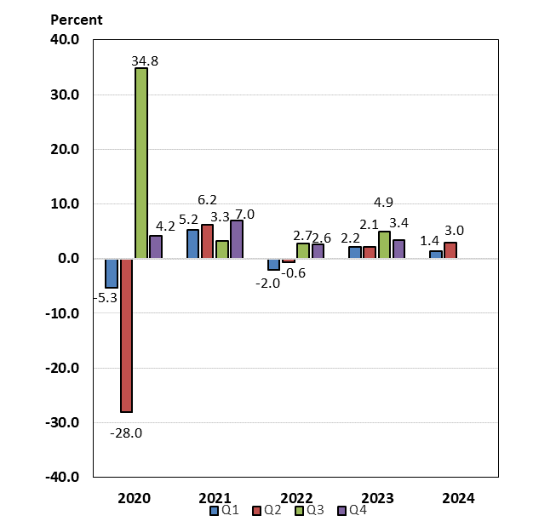

Labor Markets and Wages
Thus far in 2024, the gap between labor demand and supply has narrowed significantly. Labor markets have seen adequate levels of job growth, upward pressure on nominal wage growth has eased, and the number of job openings has neared the number of available workers.

Over the first seven months of this year, payroll job creation has slowed. After growing by 267,000 jobs per month in the first quarter of 2024, the average pace of payroll job creation slowed to 168,000 per month in the second quarter. In July, job growth slowed to 114,000. In 2024 thus far, job growth has average 203,000, a level considered adequate for the economy. Recent analysis suggests that above-trend immigration—which was postponed during the pandemic—has increased the breakeven pace of job growth needed to maintain a stable unemployment rate with population growth. According to the Federal Reserve Bank of Dallas, the upper end of estimates of breakeven job growth is around 200,000 jobs, roughly double the estimated breakeven pace before the pandemic.

Alongside slowing payroll growth, the unemployment rate has crept up a bit, though it remains historically low. Since December 2023, the unemployment rate has increased by 0.6 percentage points, reaching 4.3 percent in July; a broader measure, which captures underemployment of the workforce, has risen 0.7 percentage points over the same period to 7.8 percent. Despite these increases, both rates remain relatively low by historical standards. More timely data, unemployment insurance claims, suggest unemployment remains low. As of the latest releases for mid-August, the level of initial unemployment claims has increased by about 17 percent from the end of December, while continuing unemployment claims have drifted up by about 6 percent. Even after recent increases, these readings are only marginally above those in February 2020, just before the start of the COVID-19 pandemic in the United States.

Meanwhile, the labor force participation rate (LFPR) has increased, helping to improve labor supply, while the level of job openings has declined, on balance. The overall LFPR has risen 0.2 percentage points on the year through July to 62.7 percent, largely boosted by an increase in the LFPR for prime-age (ages 25-54) workers. The prime-age LFPR itself has risen by 0.8 percentage points so far this year, reaching a 23-year high of 84.0 percent in July. Meanwhile, labor demand—as measured by job openings (or vacancies)—has declined by about 8 percent this year, extending a downward which began in March 2022, although the most recent data in May and June (latest available) showed openings have increased modestly since April. The ratio of job vacancies to unemployed workers has gradually declined since the spring of 2022 to more reasonable levels; as of June, there were 1.2 job openings per unemployed worker, down from the pandemic-high of 2.0 vacancies and in line with the pre-pandemic high. The combination of improving supply (via above-trend immigration and higher participation) and more modest trends in job openings attests to an ongoing rebalancing of labor supply and demand.

Measures of wage growth in the private sector stabilized earlier this year but, more recently, have resumed a slowing trend. Looking at twelve-month growth rates of quarterly averages, average hourly earnings grew 4.2 percent in the first quarter of 2024, then slowed to 3.9 percent in the second quarter, and moderated further to 3.6 percent in July—the slowest yearly pace since June 2021. These annual rates are considerably below the post-pandemic peak of 5.9 percent in March 2022, but higher than the 3.0 percent rate over 2019. After slowing earlier this year due to a temporary pick-up in inflation, growth in real earnings has improved slightly. Real average hourly earnings were up 0.7 percent over the year through July 2024, up from a 0.6 percent gain over the year through March. Twelve-month gains have averaged about 0.8 percent over the most recent three months through July. An alternative measure of wage growth, the Employment Cost Index (ECI), points to a stabilization of wages pressures in recent quarters. (The ECI controls for employment shares among industries and occupations, making it a better reference for wage growth.) Over the four quarters through June 2024, the ECI for private sector wages and salaries grew 4.2 percent, after rising 4.3 percent in the first quarter. ECI growth has gradually slowed since reaching a 38-year high of 5.2 percent in March 2022.

Payroll Employment
(Monthly average for year shown and monthly amounts, in thousands)
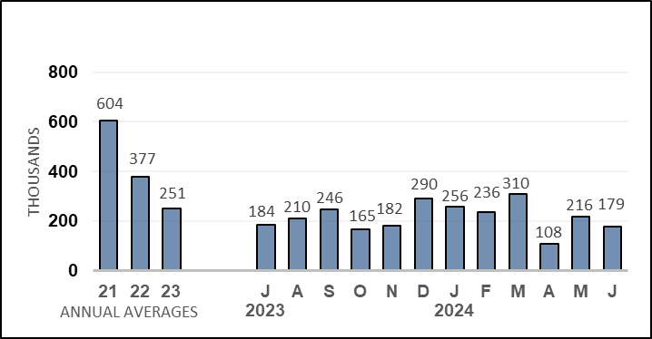

Unemployment Rate
(Percent)
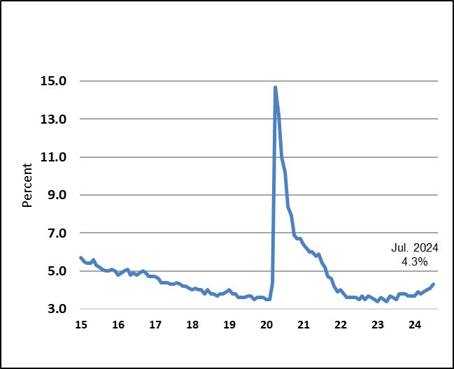

Nonfarm Productivity of Labor
With the acceleration in real GDP growth, productivity increased in the second quarter of 2024. Nonfarm productivity growth was 2.3 percent, considerably faster than the 0.4 percent increase during the first quarter of this year. The second quarter’s more rapid pace reflected a 3.3 percent jump in real output which more than offset a 1.0 percent increase in worker hours. Over the four quarters through Q2, productivity was up 2.7 percent, about double the year-earlier 1.3 percent four-quarter increase. This marked the fifth consecutive four-quarter advance.

Even with faster productivity growth in the second quarter worker compensation slowed somewhat. Nominal hourly compensation costs in the nonfarm business sector rose 3.3 percent at an annual rate in the second quarter, after a 4.2 percent increase in the first quarter. Worker compensation was up 3.2 percent over the four quarters through 2024 Q2, well down from the 4.9 percent, year-earlier pace. Despite slower nominal gains, further progress in reducing inflation helped preserve wage gains in real terms in the second quarter. Real compensation per hour grew 0.4 percent at an annual rate, matching the first quarter’s pace, although over the most recent four quarters, real compensation was flat.

Productivity gains helped contain cost growth for businesses in the second quarter, after a noticeably acceleration in the first quarter. Unit labor costs, defined as the average cost of labor per unit of output, slowed to 0.9 percent at an annual rate in the second quarter, after a 3.8 percent jump in the first quarter. Over the four quarters through Q2, growth of these costs was 0.5 percent, marking the ninth consecutive quarter of slowing on a four-quarter basis, and the smallest since an identical reading in 2019 Q3.

Industrial Production, Manufacturing, and Services
Industrial production—that is, the output of manufacturing businesses, mining, and utilities—has generally grown at a lackluster pace for the past two years. In the second quarter of 2024, output at factories, mines, and utilities increased 0.3 percent on average each month. In July, however, monthly output declined and twelve-month output growth was down 0.2 percent, partly reflecting the negative impacts of Hurricane Beryl in the Gulf region.

Manufacturing production, which accounts for about three-quarters of all industrial output, has also trended lower since autumn of 2022. Although output ticked up 0.1 percent per month, on average, in the first and second quarters, it fell 0.3 percent in July and was only 0.1 percent higher over the year. Production was pulled lower in part by the impact of Hurricane Beryl as well as a 7.8 percent plunge in automobile production in July. High-tech manufacturing continues to grow, however. For example, output of computers, communications equipment and semiconductors was up 7.3 percent over the year through July. Excluding high-tech and automotive industries, manufacturing remains generally subdued. In the second quarter, output growth increased just 0.1 percent per month on average, and output in July was 0.3 percent higher.

Mining output (14 percent of industrial production) tends to fluctuate from month to month but over the three months through July, declined by 0.9 percent and was 1.5 percent lower over the year through July. Although crude oil extraction has increased over the past year, extraction of natural gas declined as did the output of other mining industries. The final component of industrial output is utilities production, which tends to fluctuate due to weather; unseasonable weather in months often causes sharp swings in output from one month to the next. Hurricane Beryl took its toll in July, and utilities production fell by 3.7 percent, pulled down by a hurricane-related 4.3 percent drop in electricity output.

National surveys of manufacturing businesses continue to signal weak activity, while national surveys for services indicate modest expansion. The Institute for Supply Management’s (ISM) manufacturing index rose above the 50-point growth threshold in March 2024 for the first time since late 2022, but the improvement was short-lived, and as of July, the index stood at 46.8, an eight-month low and signaling mild contraction. For the services sector, the ISM’s index dipped below the growth threshold of 50 in both April and June but advanced to 51.4 in July. This index has signaled growth in the national services sector in 17 of the last 19 months.

Housing Markets

Housing market activity continued to slow on balance through mid-2024, with some loosening in recent months.

This year’s downtrend in new construction starts and permits (a signal for future starts) in the single-family and multi-family sectors has intensified. Single-family starts have declined 21.1 percent since the end of last year and were down 14.8 percent over the year through July. Single-family permits have declined 7.5 percent so far this year, and yearly rates turned negative earlier in 2024 with permits down 1.3 percent over the year through July. In the volatile multi-family sector, starts have declined noticeably over the past year or so. Thus far in 2024, starts have dropped 21.0 percent, and over the twelve months through July, were down 18.4 percent. Meanwhile, multi-family permits have declined 9.4 percent so far this year, and are down 15.1 percent over the year through July, portending future weakness in this segment of the market.

Along with declining trends in single-family as well as multi-family construction, the inventory of homes under construction has fallen by 8.3 percent this year through July as more units were completed than began construction. The total inventory of homes under construction—both single-family and multi-family—stood at 1.539 million as of July 2024, well down from the record high of 1.710 million reached in October 2022 (data series begins in 1970). Home builder sentiment has deteriorated despite recent declines in mortgage rates. The National Association of Home Builders’ housing market index declined since April and dropped to an eight-month low of 39 in August.

Meanwhile, home sales remain near lows last seen in the aftermath of the global financial crisis. However, the downtrend in existing home sales has tapered in recent months, and new home sales have trended higher recently. Existing home sales—which account for a supermajority of all home sales—have declined on a twelve-month basis every month since summer 2021. In July 2024, existing home sales were 2.5 percent lower year-over-year. Nonetheless, the decline was a fraction of the largest year-over-year drop in connection with the pandemic—36.7 percent over the year through January 2023. New single-family home sales have trended higher on balance since July 2022 and were up 5.6 percent over the year through July—though new home sales currently account for only about 15 percent of total home sales.

Inventories of existing homes available for sale have improved materially in recent months. Months’ supply of existing homes for sale rose to 4.1 months in June and stood at 4.0 months in July, a marked improvement from the all-time low of 1.6 months in January 2022. These readings are also above the 2019 average of 3.9 months of supply. Meanwhile, inventories of new homes on the market have trended lower since July 2022 and stood at 7.5 months’ supply in July 2024.

In very recent months, monthly growth rates of home prices have slowed somewhat, though annual growth rates remain higher over the year. The Case-Shiller 20-city house price index—which measures sales prices of existing homes—has risen somewhat slowly this year; in May 2024 (latest data available), the Case-Shiller price index increased 0.3 percent. Over the year ending May 2024, however, the 20-city index was up 6.8 percent, contrasting with the year-earlier, 1.7 percent decline (but well down from the 21.3 percent recent twelve-month peak rate posted in April 2022). The FHFA purchase-only house price index has been slowing since the turn of the year and was roughly flat in May. Nonetheless, over the year through May 2024, the FHFA measure was up 7.0 percent, more than double the 3.0 percent pace over the year through May 2023 (though markedly slower than the peak rate of 18.9 percent posted over the year through February 2022).

Prices
Inflation has slowed significantly from its mid-2022 peak. As measured by the consumer price index (CPI) inflation was 2.9 percent over the twelve months through July, the slowest pace since March 2021 and 6.2 percentage points lower than the peak in June 2022, though readings are still elevated relative to pre-pandemic norms. On a monthly basis, inflation readings have trended lower: in July, CPI inflation was 0.2 percent, following a decline of 0.1 percent in June and a flat reading in May.

Energy price inflation was positive in the first half of this year, but over the most recent two months, twelve-month energy inflation has trended lower, standing at just 1.1 percent over the year through July 2024. A variety of factors, bullish and bearish, have buffeted energy markets in recent months, such as widening geopolitical tensions, repeated extensions of OPEC+ production cuts, expectations of a cease-fire in the Israel-Hamas conflict, concerns about future slowing in the U.S. economy, relief over prospects for near-term monetary easing in the U.S., and weak growth in China.

Meanwhile, food price inflation has stabilized near rates observed prior to the pandemic: monthly food inflation has averaged 0.1 percent through July, slowing from the average pace of 0.2 percent during last year’s third and fourth quarters. Over the year through July, food price inflation was 2.2 percent, less than one-half the 4.9 percent, year-earlier pace.

After picking up to an average 0.4 percent during the first four months of this year, core inflation has slowed again, averaging 0.3 percent per month in May, June, and July and matching the rate during the latter half of last year. Core goods prices have been declining since mid-2023, but the pace of deflation has stabilized more recently to 0.1 percent on average during the first half of this year, after declining 0.2 percent per month on average during the latter half of 2023. In July 2024, core goods prices declined 0.3 percent and were 1.8 percent lower on a twelve-month basis.

Core services inflation, the driving force behind core CPI inflation, has slowed in recent months. In the first four months of the year, core services prices rose an average 0.5 percent per month, but over the most recent three months through July, core services inflation averaged just 0.2 percent per month. Among core services, rent of housing services (rent of primary residential and owners’ equivalent rent) contributes the largest share of core inflation, although inflation for this component has moderated considerably from the 0.7 percent to 0.8 percent monthly rates seen in the latter half of 2022. Since September 2023, rent of housing has ranged between 0.4 percent and 0.6 percent, save for a 0.2 percent in June—the lowest monthly rate since mid-2021. In July, rent of housing inflation returned to 0.4 percent. However, even with recent easing, housing inflation remains well above historical norms. Excluding rent of housing, core services inflation remains elevated as slowing of inflation for some core services has been offset by rapid paces in such services as automotive insurance and medical care.

Inflation as measured by the PCE price index is the Federal Reserve’s preferred measure of inflation, and the FOMC’s 2 percent inflation target is expressed in terms of headline PCE, although core PCE inflation is also taken into consideration. There are notable differences in weights and methodologies between the CPI and the PCE measures. Historically, twelve-month CPI inflation has exceeded PCE inflation by about 0.4 percentage points on average. This year, however, the wedge has widened, reaching 0.8 percentage points in April and averaging 0.6 percentage points through July. The excess wedge was more than explained by differences between the two inflation measures in the weight assigned to owners’ equivalent rent (OER). The CPI weighs OER more heavily, and persistently strong growth in OER since the autumn of 2021 has accounted for a significant portion of the excess wedge between the CPI and PCE measures. After trending higher earlier in 2024, headline PCE inflation was 2.5 percent over the twelve months through June, or 0.5 percentage points above the FOMC inflation target, while core PCE inflation slowed to 2.6, the slowest rate since March 2021.

Consumer Prices
(Percent change from a year earlier)
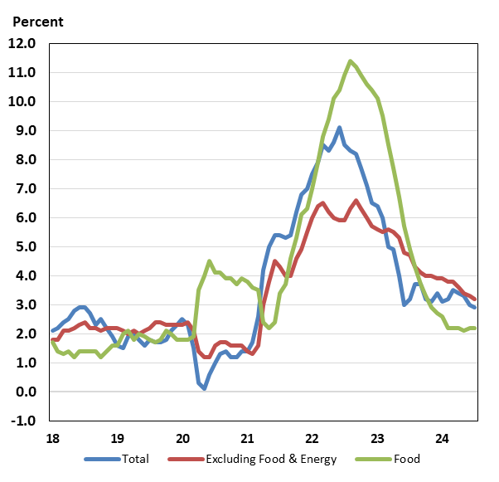

Consumer and Business Sentiment
Despite adequate job creation, rising labor force participation, strong household financial positions, and evidence of robust private consumption, consumer and business mood began to flag in the second quarter of 2024 and has remained subdued through the start of the third quarter. The Reuters/Michigan consumer sentiment index declined to 66.4 in July, an eight-month low, before edging up to 67.8 in early August—the first increase since March—as a moderate increase in the expectations component offset a further decline in the current conditions index. Consumers registered more positive views about personal finances as well as the five-year outlook and inflation expectations held steady. Consumer confidence in The Conference Board’s alternative household survey increased in August to 103.3, reflecting small gains in both the present situation and expectations components. Apart from ongoing concerns about elevated prices and interest rates currently, respondents remained relatively uncertain about the outlook for employment and business conditions.

The National Federation of Independent Business’s (NFIB) small business optimism index has decreased on balance since mid-2021; however, the survey in July indicated the fourth consecutive month of improved optimism as the index rose to its highest level since February 2022. Nonetheless, pessimism among small business owners persists, and while July’s reading was above the pre-pandemic low, it remains four points below the 50-year average of 98. Owners of small businesses continued to express concerns about the quality of labor, high input costs, and a limited degree of pricing power.

Federal Budget Deficit and Debt
In FY 2023, the deficit increased $320 billion to $1.70 trillion, equal to 6.3 percent of GDP, as lower receipts outweighed decreased spending. Receipts shrank by $457 billion FY 2023, reflecting in part lower capital gains realizations and lower deposits of Federal Reserve earnings. Outlays decreased by $137 billion in FY 2023, partly reflecting the rescission of planned student loan forgiveness and the expiration of the expanded Child Tax Credit, among other provisions. By contrast, outlays for national defense, Social Security, Medicare, and net interest all had large increases.

So far in FY 2024, federal finances have continued to improve relative to the comparable period in FY 2023. For Fiscal Year to Date (FTYD) 2024, which runs from October 2023 to the present (July 2024), the federal deficit was $1,517 billion, $97 billion lower than in the previous FYTD. Federal receipts were $4,085 billion in FYTD 2024, up $396 billion (10.7 percent) from the same FYTD a year ago, reflecting an increase in income tax receipts. Federal outlays were $5,602 billion, up $299 billion (5.6 percent) from the same FYTD a year ago, due to increased outlays for national defense and net interest payments, as well as somewhat higher spending on Social Security and Medicare and Medicaid payments.

In June 2023, the Treasury’s borrowing limit was suspended until early 2025. During the first ten months of FY2024, gross federal debt stood at $35.1 trillion while debt held by the public was $27.9 trillion.

Monetary Policy
The Federal Open Markets Committee (FOMC) began raising its policy rate at its meeting in March 2022 to address inflationary pressures in the economy. Tightening amounted to 425 basis points that year, followed by another 100 basis points of tightening in 2023. At its most recent meeting on July 30-31, the FOMC maintained its short-term policy rate target (the federal funds rate, or FFR) at 5.25–5.50%, unchanged since mid-2023.

During the post-FOMC meeting press conference on July 31, Chair Powell observed that “We’ve stated that we do not expect that it will be appropriate to reduce the target range for the federal funds rate until we have gained greater confidence that inflation is moving sustainably toward 2 percent. The second quarter’s inflation readings have added to our confidence, and more good data would further strengthen that confidence.”

