Profile of the Economy
(Office of Macroeconomic Analysis)
November 16, 2023
Introduction
The U.S. economy posted robust growth in the third quarter, amid tight, but cooling, labor markets and easing inflationary pressures. Real GDP growth more than doubled in the third quarter, while employment growth accelerated from June to September. Although job growth slowed to150,000 in October, the pace remains sufficient to keep the unemployment rate relatively low and stable—though the headline unemployment rate has moved up recently, owing to improved labor force participation. Meanwhile, inflation has trended lower this year through October. The headline inflation rate (as measured by the consumer price index, or CPI) has dropped by nearly 6 percentage points from its peak in June 2022 through October 2023, reflecting energy price deflation and food price disinflation. In addition, core inflation has eased, largely reflecting drag from core goods prices.
Economic Growth
Real GDP growth accelerated to 4.9 percent at an annual rate in the third quarter, picking up smartly from a 2.1 percent gain in the second quarter and the fastest pace of growth since late 2021. Robust growth in consumption and an upturn in private inventory investment propelled the acceleration, along with increased contributions from total government spending.

GDP can be decomposed into four major components: (1) private domestic final purchases (PDFP), the most persistent and stable components of output, including personal consumption, business fixed investment, and residential investment; (2) government consumption and investment; (3) net international purchases; and (4) intermediate demand (or the change in private inventories). Examined separately, each component delivers specific information about activity in various sectors that can be useful in predicting the future path of growth.

PDFP is an especially important component of GDP: it measures the private sector’s capacity to drive self-sustaining growth and, therefore, can signal the direction of future economic performance. In the third quarter, real PDFP growth accelerated to 3.3 percent at an annual rate and contributed 2.8 percentage points to total GDP growth. Changes in the components of PDFP were largely positive. Personal consumption expenditure (PCE) growth quintupled to 4.0 percent in the third quarter, as resilient households increased their spending in all categories of consumption. Spending on durable goods growth accelerated to 7.6 percent in the third quarter—with automotive purchases accounting for about half of the swing in the contribution from durable goods—while nondurable goods consumption rose by 3.3 percent. Meanwhile, the pace of growth in consumption of services more than tripled to 3.6 percent in the third quarter, a pick-up largely due to three service sectors: housing and utilities, food services and accommodations, and other services.

The second piece of PDFP—business fixed investment (BFI)—declined slightly in the third quarter, as spending on equipment fell and the pace of structures investment slowed. Equipment investment has fluctuated widely in recent quarters, decreasing by 3.8 percent in the third quarter after a 7.7 percent gain in the previous quarter. The decline in spending on equipment mostly reflected a reversal in investment in transportation equipment. Although investment in structures slowed to 1.6 percent growth from double-digit surges in the first half of the year, factory investment continued to increase. Meanwhile, investment in intellectual property products (IPP) remained positive for the thirteenth consecutive quarter, growing by 2.6 percent in the third quarter. Nonetheless, investment in this category has slowed substantially in recent quarters.

The final component of PDFP—private residential investment—registered growth in the third quarter for the first time since early 2021. In the third quarter, residential investment rose 3.9 percent, following a 2.2 percent decline in the previous quarter. The upturn was largely driven by permanent site construction of single-family and multi-family structures. However, spending on other structures, a category that includes brokers’ commissions and home improvements, declined in the third quarter, likely reflecting exceptionally low existing home sales and limited inventories amid high interest rates.

Two of the other three components of GDP made positive contributions to third quarter growth. Total government spending growth accelerated noticeably in the third quarter, rising 4.6 percent after a 3.3 percent gain in the previous quarter. Federal expenditures advanced 6.2 percent—reflecting a faster pace of federal spending growth on national defense—while the growth rate of state and local government spending eased to 3.7 percent. Meanwhile, the change in private inventories (CIPI), which can exhibit wide swings from quarter to quarter, added 1.3 percentage point to real GDP growth in the third quarter, after having a neutral impact in the second quarter. The stronger contribution reflected stronger inventory growth among manufacturers and retailers as well a slower drawdown in wholesalers’ inventories.

Meanwhile, international trade was a net negative contributor to real GDP growth in the third quarter, as import growth outweighed the increase in exports. This was the first quarter since early 2022 in which net exports posed a drag on GDP growth. The net export deficit increased by $9.5 billion in the third quarter at -$937.7 billion, subtracting 0.1 percentage point from third quarter GDP growth. Total exports of goods and services grew 6.2 percent at an annual rate while total imports grew by 5.7 percent.

Growth of Real GDP
(Quarterly percent change at annual rate)
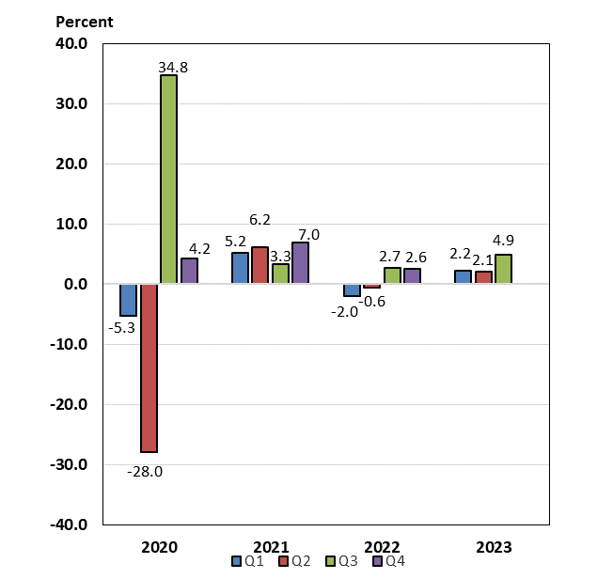

Labor Markets and Wages
Labor markets have remained tight thus far in 2023, but signs of easing are building. The pace of job creation averaged 257,000 per month in the first half of this year, slowed to an average 233,000 per month in the third quarter, and eased further to 150,000 in October. Nonetheless, this pace of job creation remains sufficient to maintain a stable unemployment rate with a constant labor supply—though the latter has gradually improved this year, leading to a higher unemployment rate. After dropping to a 54-year low of 3.4 percent in January 2023 and again in April, the unemployment rate subsequently has trended higher. In the third quarter, the unemployment rate averaged 3.7 percent and stood at 3.9 percent as of October. Similarly, the broadest unemployment rate—which includes those working part-time for economic reasons and those marginally-attached to the labor force—has risen to 7.2 percent in October, noticeably above the record low of 6.5 percent set in December 2022 (series dates from 1994).

The imbalance between labor supply and demand in the economy has continued to improve this year, albeit slowly. Labor force participation rates (LFPR) for all workers, as well as prime-age (ages 25-54) workers, have trended higher thus far in 2023. Between March and July 2023, the headline LFPR held steady at 62.6 percent—its highest level since March 2020—but moved up to 62.8 percent in August and September before ticking down to 62.7 percent in October 2023. Among prime-age workers, the LFPR has surpassed the pre-pandemic high of 83.1 percent since April, peaking 0.4 percentage points higher in three of those months, and stood at 83.3 percent as of October 2023. Even the participation of workers aged 55 and over has moved up sharply in recent months, rising from 38.3 percent in July 2023 to 38.8 percent in August and September, before stepping down to 38.6 percent in October. Even so, the latter is 1.7 percentages points below the 40.3 percent rate posted in February 2020, largely due to demographic pressures as Baby Boomers retire. In addition to increased labor supply, demand for labor is slowly normalizing. The number of job openings and the vacancies rate have each trended down since March 2022; as of September 2023 (latest available data), there were 1.5 job openings per unemployed worker, the lowest ratio since September 2021. This lower ratio (fewer jobs per unemployed worker) signals improving balance in labor markets.

Measures of wage growth in the private sector show a gradual slowing. Average hourly earnings rose 4.1 percent over the twelve months through October 2023, gradually slowing from the 5.9 percent peak in March 2022. After adjusting for inflation, real average hourly earnings were up 0.8 percent over the year through October 2023, partly reversing the 2.7 percent decline in real wages over the year-earlier period. An alternative measure of wage growth, the Employment Cost Index (ECI), also suggests that wage pressures moderated in the third quarter. (The ECI controls for employment shares among industries and occupations, making it a better reference for wage growth.) Over the four quarters through September 2023, the ECI for private sector wages and salaries grew 4.5 percent, slowing from the previous year’s four-quarter pace of 5.2 percent. On a quarterly basis, after slowing dramatically in the second quarter, wage growth in goods-producing industries picked up to 3.3 percent (annual rate) in the third quarter. Meanwhile, wage growth in service-providing industries slipped to 4.3 percent in the third quarter, following four consecutive quarters of stable growth around 4.6 percent.

Payroll Employment
(Monthly average for year shown and monthly amounts, in thousands)

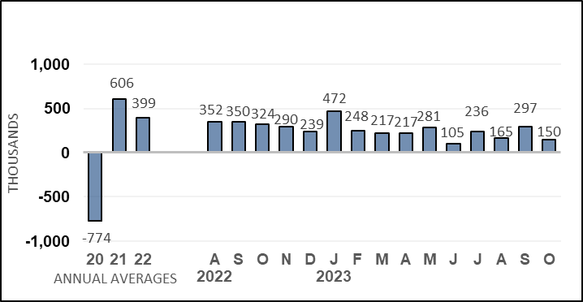

Unemployment Rate
(Percent)
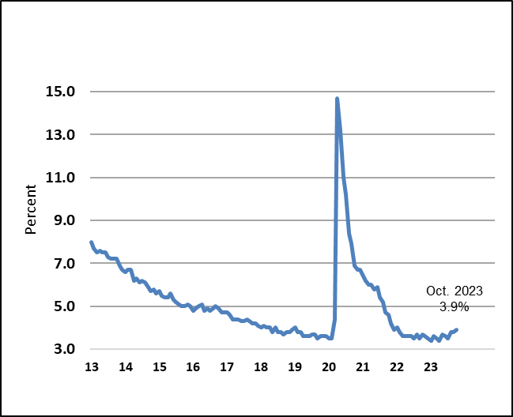

Nonfarm Productivity of Labor
Nonfarm productivity growth accelerated in the third quarter, as output growth offset a small increase in worker hours. Productivity growth was up 4.7 percent at an annual rate in this year’s third quarter, following a 3.6 percent rise in the second quarter. The third-quarter gain—which was the fastest since the third quarter of 2020—reflected a 5.9 percent advance in output that was partly countered by a 1.1 percent increase in worker hours. Over the four quarters through the third quarter of 2023, productivity was up 2.2 percent, the second consecutive four-quarter increase. This back-to-back advance followed five consecutive twelve-month declines.

Nominal hourly compensation costs in the nonfarm business sector rose 3.9 percent at an annual rate in the third quarter of 2023, decelerating from the 6.9 percent pace in the second quarter. Compensation costs rose by 4.2 percent over the four most recent quarters, picking up from the 3.9 percent, year-earlier pace. Growth of unit labor costs, defined as the average cost of labor per unit of output, decreased by 0.8 percent in the third quarter, after increasing 3.2 percent in the previous quarter. On a four-quarter basis, however, these costs grew 1.9 percent over the most recent four quarters, nearly one-third of the 5.7 percent year-earlier pace.

Industrial Production, Manufacturing, and Services
Total industrial production has been volatile over the first ten months of 2023—though it has trended higher. Since December 2022, output at factories, mines, and utilities has increased 1.2 percent.

Manufacturing production, which accounts for about 74 percent of all industrial output, rose 1.1 percent from December 2022 to October 2023. Automotive output had trended higher from March through September before dropping 10.0 percent in October, which related to the now-resolved United Auto Workers’ strike. Output at select high-technology factories held steady at 1.4 percent in October and excluding motor vehicles and parts and high-technology industries, manufacturing output was flat in October.

Output at mines has risen 5.0 percent, including a 0.4 percent increase in October. Twelve-month rates have slowed with easing energy prices: mining output was 2.2 percent over the year through October, much slower than the 7.4 percent, year-earlier advance. Utilities output, the remaining 10 percent of total industrial output, has also fluctuated from month to month; weather is usually a factor contributing to swings in this sector; unseasonable weather in months often causes sharp swings in output from one month to the next. Utilities output declined 1.6 percent in October, but over the 12 months through October 2023, utilities production was up 2.9 percent.

According to survey measures of manufacturing and service-sector businesses, growth remains negative in manufacturing, and has slowed significantly in services. The Institute for Supply Management’s (ISM) manufacturing index has remained below the 50 level for the past twelve months. In October 2023, the index stood at 46.7. For the services sector, the ISM’s index dipped below 50 in December 2022 but has held above 50 for the past ten months. In October 2023, the index fell 1.8 points to 51.8. This index has signaled expansion in 40 of the past 41 months but recent readings have indicated much slower growth.

Housing Markets

Although residential investment grew in the third quarter, further tightening of monetary policy and rising mortgage rates combined with elevated house prices weighed on home affordability and housing activity. In September 2023, existing home sales—which account for nearly 90 percent of all home sales—declined 2.0 percent over the month and were 15.4 percent lower on a twelve-month basis. By contrast, new single-family home sales have trended higher since July 2022 and jumped 12.3 percent in September, bringing the 12-month gain to 33.9 percent. Inventories of existing homes available for sale have risen from all-time lows in 2022 but remain constrained as many existing homeowners are still reluctant to sell homes with lower mortgage rates in exchange for new mortgages at much higher rates. Even so, the months’ supply of existing homes for sale has been edging up in recent months and stood at 3.4 months in September—more than double the supply available in January 2022, an all-time low—but still well below the average 3.9 months of supply in 2019. Inventories of new homes on the market remain elevated but have declined: after surging above 10 months’ supply in July 2022, months’ supply has trended lower, and stood at 6.9 months in September 2023.

Since early 2023, monthly growth rates of house prices have been picking up, although yearly rates continue to slow or even decline. The Case-Shiller 20-city house price index—which measures sales prices of existing homes—declined each month between July 2022 and January 2023 but has risen since March; in August, the 20-city index was up 1.0 percent over the month (latest data available). On a twelve-month basis, however, the index declined between March and June 2023, the first yearly declines since early 2012. By August, the Case-Shiller index was up 2.2 percent year-over-year—although this pace was still slower from the 13.2 percent, year-earlier advance. The FHFA purchase-only house price index showed flat or slightly positive growth between October 2022 and January 2023 but, starting in February, has shown robust monthly growth—including a 0.6 percent advance in August. Twelve-month rates remain positive but have trended lower; over the year through August 2023, this index was up 5.6 percent, roughly one-half the pace of 11.9 percent over the year through August 2022.

Signals from new construction starts and permits for future starts have been mixed thus far in 2023, and the divergence between the single-family and multi-family sectors has widened. Single-family housing starts have been trending higher since late last year, including a 3.2 percent advance in September. Twelve-month growth rates have turned positive following the sharp declines that prevailed from May 2022 through June 2023. Over the year through September 2023, single-family starts were up 8.6 percent. Similarly, after declining for eleven consecutive months through the end of 2022, single-family permits have been growing in 2023, including a 1.6 percent gain in September. Yearly rates turned positive in July and were up 11.3 percent over the twelve months through September. In the volatile multi-family sector, starts had been running at an elevated pace since late 2021 but have declined noticeably in recent months; nonetheless, monthly starts in this sector jumped 17.6 percent in September. Meanwhile, permits have declined in six of the past nine months, including a 14.3 percent decline in September. Multi-family permits are down 23.1 percent year-to-date, suggesting a weakening trend in this segment of the market.

Despite mixed trends between single-family and multi-family construction, activity in the housing sector remains relatively elevated, as builders continue to work through construction backlogs. The number of total homes under construction—both single-family and multi-family—stood at 1.676 million as of September 2023, modestly below the record high of 1.710 million reached in October 2022 (data series begins in 1970). Earlier this year, home builders had grown more optimistic about conditions in single-family housing markets, with the National Association of Home Builders’ housing market index rising to 56 in July, the highest reading since June 2022. More recently, however, builder sentiment has deteriorated. This index fell to 40 in October, moving closer to the recent low of 31 in December 2022.

Prices
Inflation has slowed substantially since 2022. Although inflation picked up in the third quarter, it was largely due to rising energy prices that have since faded. In the third quarter, headline inflation (as measured by the CPI) averaged 0.4 percent, driven by an average 2.4 percent rise in energy prices from June to September. By contrast, inflation in October was flat owing in part to a 2.5 percent drop in energy prices. Meanwhile, food inflation has trended lower since mid-2022 when it peaked at 1.1 percent month-over-month. In October, monthly food price inflation was 0.3 percent, just above the year-to-date average monthly rate.

Core CPI inflation (which strips out the volatile energy and food components) was elevated for much of 2022 but slowed to a range of 0.3 percent to 0.4 percent during the final three months of the year. Core inflation has moderated further this year: in October 2023, core prices increased just 0.2 percent—below the twelve-month average monthly rate of 0.3 percent. Core goods price inflation has constrained core inflation readings, having declined in each of the past five months; in October, the core goods CPI declined 0.1 percent. By contrast, inflation for core services has been the driving force behind core CPI inflation in 2023. Rent of housing inflation—that is rent of primary residence and owners’ equivalent rents—has set a high floor for core services inflation, despite some recent slowing. Monthly rent of housing inflation readings have fluctuated between 0.4 percent and 0.5 percent since March, accounting for roughly 0.2 percentage points of monthly inflation. Even so, rent of housing price growth has moderated from the 0.7 percent to 0.8 percent monthly rates seen in the latter half of 2022.

On a twelve-month basis, inflation has also slowed considerably from peak readings but is still elevated relative to pre-pandemic paces and above the Federal Reserve’s target rate. Over the year ending October 2023, CPI inflation was 3.2 percent—nearly one-third of the 9.1 percent pace recorded over the year through June 2022. Energy prices dropped 4.5 percent over the twelve months ending in October 2023, in contrast with the 41.6 percent twelve-month rise seen in June 2022—the peak rate following the Russian invasion of Ukraine. After running at double-digit paces for nine consecutive months, food price inflation slowed to single digits as of February 2023 and, over the year through October 2023, was 3.3 percent—the slowest twelve-month pace since June 2021. Core inflation has also slowed on a yearly basis, but to a lesser extent than headline: over the year ending in October 2023, core inflation was 4.0 percent, or 2.6 percentage points below the peak rate of 6.6 percent reached over the year through September 2022 and the slowest yearly pace since September 2021. As with monthly inflation, price growth of core services—driven by strong shelter inflation—was the primary contributor to relatively rapid core inflation. After running at 7.3 percent over the year through February 2023—the fastest rate in over forty years—core services price inflation slowed to 5.5 percent over the twelve months through October – largely driven by shelter inflation (despite slower monthly readings of late). Over the year through October 2023, core goods inflation was 0.1 percent, a fraction of the peak yearly rate of 12.3 percent through February 2022.

The Federal Reserves’ preferred measure of inflation is the PCE price index. The PCE price index assigns different weights for different components than does the CPI and uses a different methodology in its calculation—though the drivers of both measures remain similar. Inflation as measured by the PCE price index typically runs at a slower pace than CPI inflation due to these methodological and weighting differences. As of September 2023, PCE inflation was 3.4 percent on a year-over-year basis, 0.3 percentage points slower than CPI inflation for the comparable timeframe. Core PCE inflation was 3.7 percent over the year ending September 2023, 0.4 percentage points below the 4.1 percent inflation as measured by the core CPI over the same time frame.

Consumer Prices
(Percent change from a year earlier)
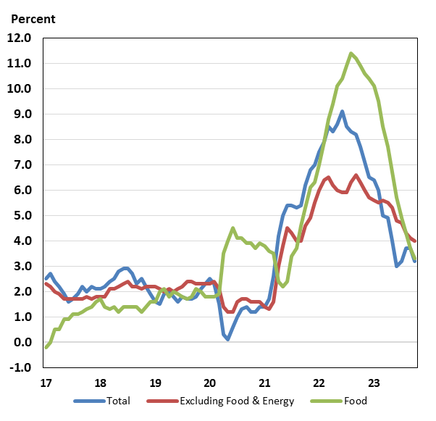

Consumer and Business Sentiment
Consumer and business sentiment measures have decreased further in recent months—despite slowing inflation and comparatively strong labor markets—as concerns about personal finances and employment, longer-term inflation expectations, and geo-political strife all rose. The Reuters/Michigan consumer sentiment index reached a record low of 50.0 in June 2022 (series debuted in November 1952). Although it trended higher during the first half of 2023, the index has now declined for four consecutive months, standing at just 60.4 in the early November survey. Meanwhile in The Conference Board’s alternative household survey, the consumer confidence index has declined in each of the past three months, reaching 102.6 in October 2023.

On the business side, the National Federation of Independent Business’s (NFIB) small business optimism index has trended lower since mid-2021. As of October 2023, the small business optimism index stood at 90.7, or 0.2 points below the early pandemic low. This marked the twenty-second consecutive month that the index was below the pre-pandemic long-term average of 98.0.

Federal Budget Deficit and Debt
The federal government’s deficit and debt rose sharply following the multiple fiscal responses to mitigate the pandemic’s impact on the economy. In FY 2020, the federal deficit peaked at 14.7 percent of GDP. However, federal finances have improved significantly since FY 2020. By FY 2022, the deficit had decreased to 5.4 percent of GDP, reflecting the phasing out of pandemic-related aid and recovery in the economy more broadly.
For FY 2023, the deficit increased $320 billion to $1.70 trillion, equal to 6.3 percent of GDP, as lower receipts outweighed decreased spending. Receipts shrank by $457 billion from FY 2022 to FY 2023. The decrease was related to more normal capital gains realizations in 2022—taxes of which are paid in FY 2023—whereas historically high realizations in 2021 had boosted receipts in FY 2022. Outlays decreased by $137 billion in FY 2023, partly reflecting the impact of Biden v. Nebraska on certain student loan relief programs. However, the decrease in the Department of Education’s net outlays was offset by higher outlays for national defense, Social Security, Medicare, and net interest.
At the end of FY 2023, gross federal debt stood at 122.9 percent of GDP ($33.2 trillion), up from 122.2 percent of GDP ($30.9 trillion) at the end of fiscal year 2022. Debt held by the public was $2632 trillion (97.6 percent of GDP) at the end of FY 2023, up from $24.3 trillion by the end of fiscal year 2022 (96.0 percent of GDP). In June 2023, the Treasury’s borrowing limit was suspended until 2025.
Economic Policy
In August 2023, the Administration celebrated the one-year anniversary of the Inflation Reduction Act (IRA), which sought to improve the resiliency of supply chains—which had been disrupted in late-2021 and early-2022 and contributed to rising inflation—and address other long-run supply-side vulnerabilities, particularly those arising from climate change. The IRA included provisions to reduce health care costs for prescription drugs and health care coverage as well as an additional $370 billion for measures to reduce emissions and substantial deficit reduction through improved tax compliance and closing of tax loopholes.

The current cycle of monetary policy tightening, which began at the FOMC’s March 2022 meeting to address inflation, has slowed in 2023. So far this year, the FOMC has increased the interest by 100 basis points—versus a 425-basis point increase in 2022—and has not raised the target range since July. The Federal Reserve also has been reducing its holdings of long-run assets of Treasury securities and mortgage-backed securities (MBS), putting upward pressure on longer-term interest rates. The FOMC’s balance sheet runoff—that is, allowing maturity of longer-term assets without reinvestment—began on June 1, 2022. Through the week-ending Wednesday, November 15, the Fed’s holdings of Treasury securities and agency mortgage-backed securities (MBS) have declined 13.8 percent to $7.3 trillion since the FOMC initiated quantitative tightening (QT) on June 1, 2022.

