OTCnet Deposit Processing A/C/R Instructions
Updated 05/01/2019

Section 1: Overview

The OTCnet Deposit Processing A/C/R process is changing to utilize the Commercial Voucher Entry Form.
- Clients requesting a Correction to the ALC, CAN, Voucher Number, or Voucher Date will need to complete TWO (2) request forms per A/C/R request – one form to reverse/offset the existing transaction (hereafter referred to as the Offset Form – see Section 2) and one form to enter the correct information (hereafter referred to as the Correction Form – see Section 3). The Offset Form will contain all of the original voucher information (see below for details) with one exception. The Voucher Type (Credit or Debit) will be reversed to create an offset of the original voucher (ex: if the original deposit voucher is a credit to the agency. In this case, the Offset Form would be a debit and then the Correction Form would be a credit).
- Clients requesting a Rescission or an Amount Adjustment can fill out only one form. For a Rescission Request, complete only an Offset Form to zero out the original voucher. For an Amount Adjustment request, complete only a Correction form.

To acquire the information for this form, you will need to refer to the OTCnet Deposit Voucher information screen. To access this screen:

- Go to Deposit Processing
- Select Search Deposit (or Search Adjustment if the voucher is an adjustment)
- Enter the 6-digit deposit voucher number into the Voucher # field
- Click the Search button at the bottom
- At the bottom of the page, click on the deposit voucher number to open the deposit voucher information screen.

Special Notes:
- The deposit voucher status must be CONFIRMED to request an A/C/R against the voucher.
- An A/C/R request that changes the CAN or Amount of a deposit voucher must come from the Financial Institution (FI) that processed the deposit. Agencies that wish to dispute the settlement amount of a deposit will need to contact the FI rather than submitting an A/C/R request.
- The Financial Institution should only submit an amount change A/C/R if the option to create an adjustment within OTCnet is unavailable.
- All reference to credit or debit is made from the perspective of the government agency, so credits are funds added to an agency’s account and debits are funds removed from an agency’s account.

Email all completed forms to the OTCnet Helpdesk at FiscalService.OTCChannel@citi.com to be processed.
For questions regarding the A/C/R process, contact the OTCnet Helpdesk at FiscalService.OTCChannel@citi.com or 866-945-7920.
Searching Deposits or Adjustments

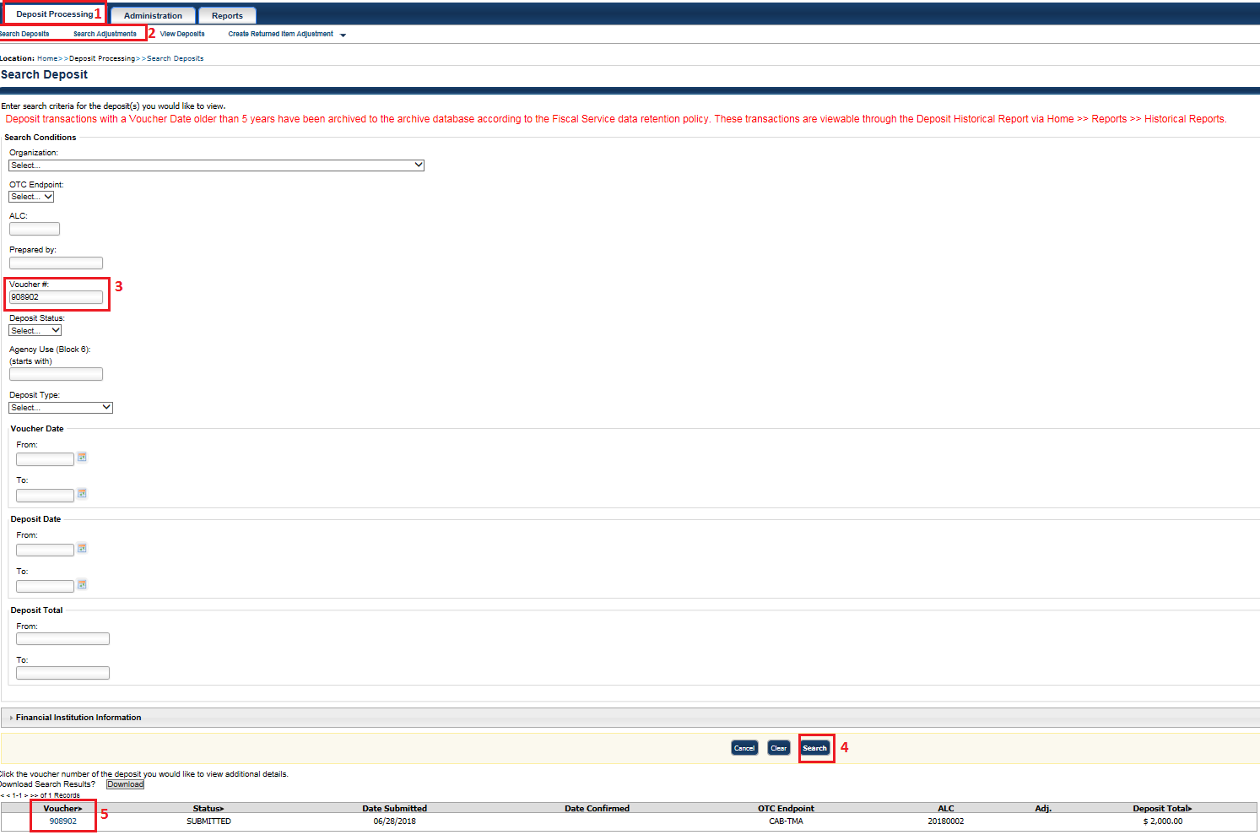
Section 2: Required Fields for the Offset Form

Before the form can be saved, the required fields (colored pink) must be completed in full and in sequence from the top of the form. The required fields may change as you select different options, so please ensure all required fields are completed. The fields not colored pink are optional, and it is recommended that you leave them blank.

Batch Information Section

Trading Partner: Select OTC-Net TGA

Deposit Date: Enter the Date of Deposit as it appears in the OTCnet deposit voucher information. Format must be MM/DD/YYYY (ex. 01/01/2018).

General Voucher Information Section

Source Voucher ID: Enter the number 1 into this field.

Voucher Date: Enter the Voucher Date as it appears on the OTCnet deposit voucher information using MM/DD/YYYY format.

Voucher Number: Enter the 6-digit Deposit Voucher Number (ex. 200101) for the original deposit voucher.

Voucher Type: Select 5515 (Debit) if the funds should be removed from an agency’s account. Select 215 (Credit) if the funds should be added to an agency’s account. This should be the opposite type of the original voucher.

Voucher Amount: Enter the total amount of the voucher as it is currently listed on the OTCnet deposit voucher information.

IRS Tax Collection: If the voucher is not an IRS voucher, select Non-Tax. Otherwise, select the Tax option.

ALC: Enter the 8-digit ALC as it is currently listed on the OTCnet deposit voucher information (ex. 12345678).

A/C/R Indicator: Select Yes

RTN: Enter the 9-digit routing number (RTN) as it is currently listed on the OTCnet deposit voucher information.

FI Comments: Enter comments stating why the A/C/R request is being submitted and detailing the desired outcome.

Agency Comments: If the agency does not request a particular comment for their vouchers, this field should be left blank.

Classification: Select Unknown

Reporting Program/Subprogram: Select Bank Deposit

CAN: Enter the 6-digit Cashlink Account Number (CAN) as it is currently listed on the OTCnet deposit voucher information.

Additional Voucher Information Section

Channel Type: Select OTC

Tax Information Section

This section is for IRS vouchers only. If the form is being submitted for an IRS voucher, complete the Tax Information fields. Please note, the sum of all tax amounts must equal the voucher amount.

Adjustments / Correction / Rescinds (A/C/R) Section

A/C/R Type & Reason Code –
- Voucher Date, Voucher Number, CAN, or ALC Change Request: Select Correction as the A/C/R Type and Other as the Reason Code
- Reversal of Voucher Request: Select Rescind as the A/C/R Type and Erroneous Submission as the Reason Code

Section 3: Required Fields for the Correction Form

Before the form can be saved, the required fields (colored pink) must be completed in full and in sequence from the top of the form. The required fields may change as you select different options, so please ensure all required fields are completed. The fields not colored pink are optional, and it is recommended that you leave them blank.

Batch Information Section

Trading Partner: Select OTC-Net TGA

Deposit Date: Enter the Date of Deposit as it appears on the OTCnet deposit voucher information. Format must be MM/DD/YYYY (ex. 01/01/2018).

General Voucher Information Section

Source Voucher ID: Enter the number 1 into this field.

Voucher Date: Enter the Voucher Date as it is listed on the OTCnet deposit/adjustment voucher information. If the request is for a voucher date change then enter the corrected voucher date.

Voucher Number: Enter the 6-digit Deposit Voucher Number (ex. 200101) for the original deposit/adjustment voucher. If the request is for a voucher number change then enter the corrected voucher number.

Voucher Type: If the request is for an Amount Adjustment, select 5515 (Debit) if the funds should be removed from an agency’s account or 215 (Credit) if the funds should be added to an agency’s account. Otherwise, select the same Voucher Type as the original voucher.

Voucher Amount: If the request is for a voucher amount change, then enter the difference between the original amount and the desired amount (ex: if changing a $10.00 voucher into a $100.00 voucher, this field would be $90). Otherwise, enter the amount as it is listed on the OTCnet deposit/adjustment voucher information.

IRS Tax Collection: If the voucher is not an IRS voucher, select Non-Tax. Otherwise, select the Tax option.

ALC: If the request is for an ALC change, then enter the corrected ALC. Otherwise, enter the ALC as it is listed on the OTCnet deposit/adjustment voucher information.

A/C/R Indicator: Select Yes

RTN: Enter the 9-digit routing number (RTN) as it is currently listed on the OTCnet deposit voucher information.

FI Comments/Agency Comments: Enter comments stating it is the Correction Form and detail your desired outcome for the A/C/R submission.

Classification: Select Unknown

Reporting Program/Subprogram: Select Bank Deposit

CAN: If the request is for a Cashlink Account Number (CAN) change, then enter the corrected 6-digit CAN. Otherwise, enter the CAN as it is listed on the OTCnet deposit/adjustment voucher information.

Additional Voucher Information Section

Channel Type: Select OTC

Tax Information Section

This section is for IRS vouchers only. If the form is being submitted for an IRS voucher, complete the Tax Information fields. Please note, the sum of all tax amounts must equal the voucher amount.

Adjustments / Correction / Rescinds (A/C/R) Section

A/C/R Type & Reason Code –
- Amount Adjustment Request: Select Adjustment as the A/C/R Type and Amount Exception as the Reason Code
- Voucher Date, Voucher Number, CAN, or ALC Change Request: Select Correction as the A/C/R Type and Other as the Reason Code

**As a reminder, only the pink highlighted fields are required.**
Section 3: Saving the Form(s)

After you have completed the forms, they must be saved using the following naming format:

Naming Convention: Current Date (ALC) (Voucher #) (Form Type) (Amount)

- Current Date: YYYY-MM-DD format
- ALC: the 8 digit ALC on the form
- Voucher #: the 6 digit voucher # on form
- Form Type: 215 or 5515 - should be the same as what was chosen on form
- Amount: the amount of the voucher without commas or dollar sign

Example of naming Convention for Debit Request: 2019-05-01 (12345678) (654321) (5515) (1000.00)
Example of naming Convention for Credit Request: 2019-05-01 (12345678) (654321) (215) (1000.00)

If you have multiple requests will end up with the same name based on the formatting, then a 1, 2, 3, etc. should be added at the end in parenthesis.

Examples of this scenario:
- 2019-05-01 (12345678) (654321) (5515) (1000.00) (1)
- 2019-05-01 (12345678) (654321) (5515) (1000.00) (2)

Finally, when saving the form please ensure that the Macros are enabled. If you see the warning that the Macros have been disabled, click the "Enable Content" button before saving the form.

Example Forms for ALC Switch (Offset)

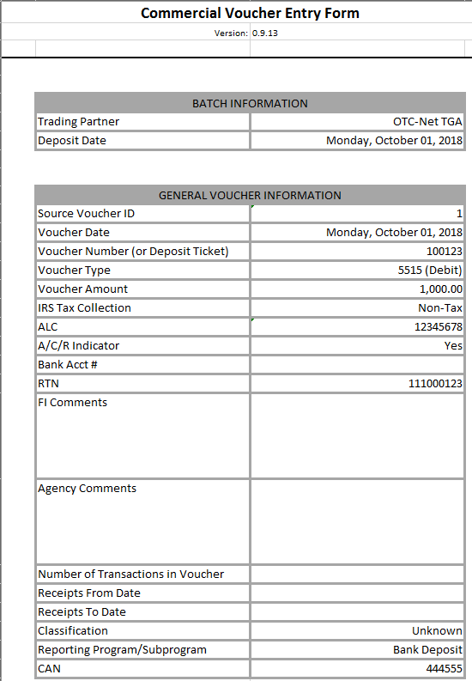 | 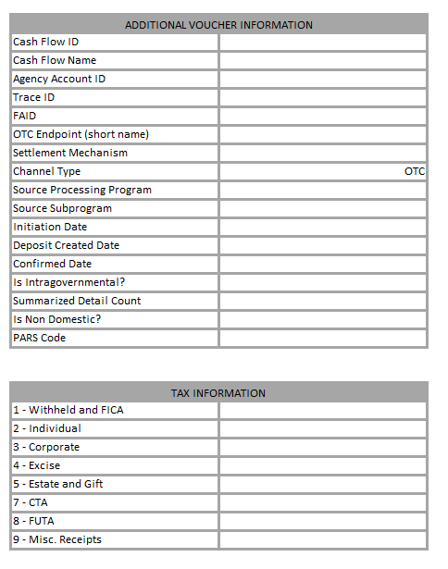

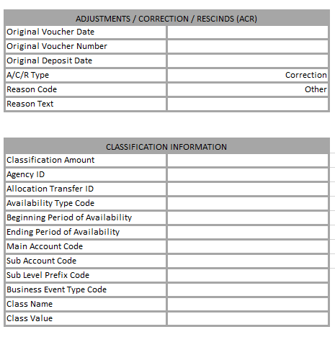 | 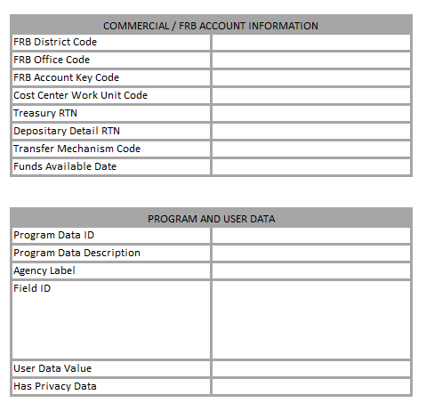

Example Forms for ALC Switch (Correction)

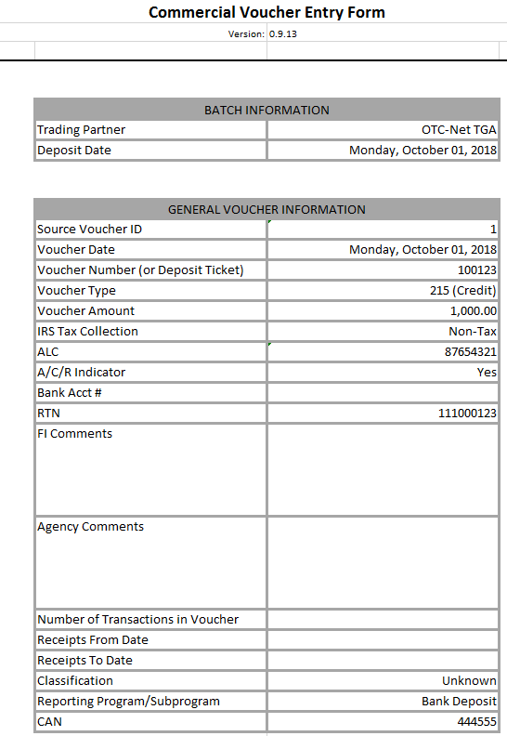 | 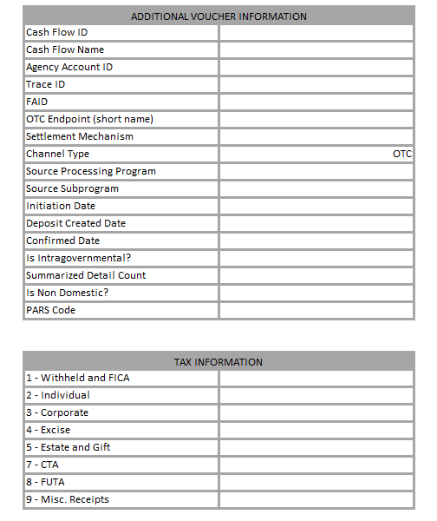

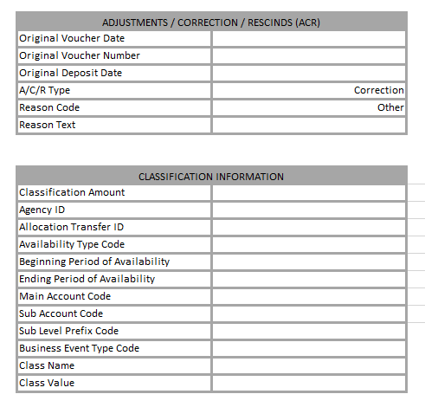 | 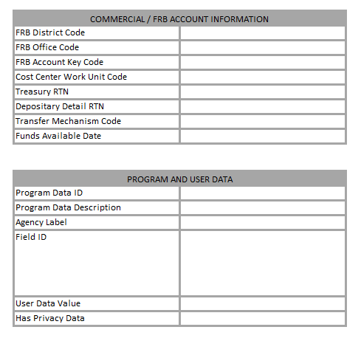

Example Form for Amount Adjustment (Correction Only)

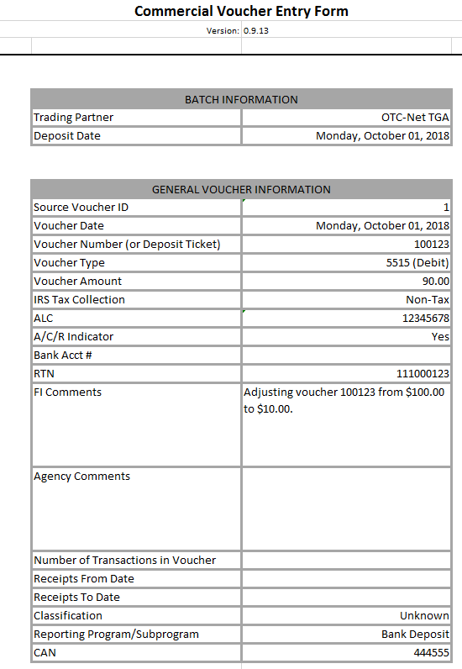
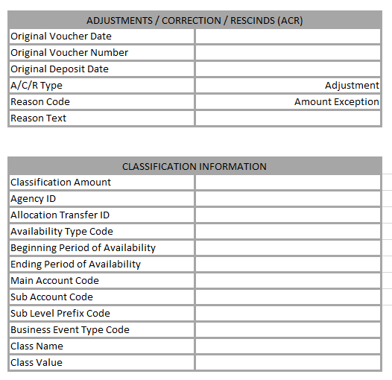

Example Form for Rescind (Offset Only)

