.

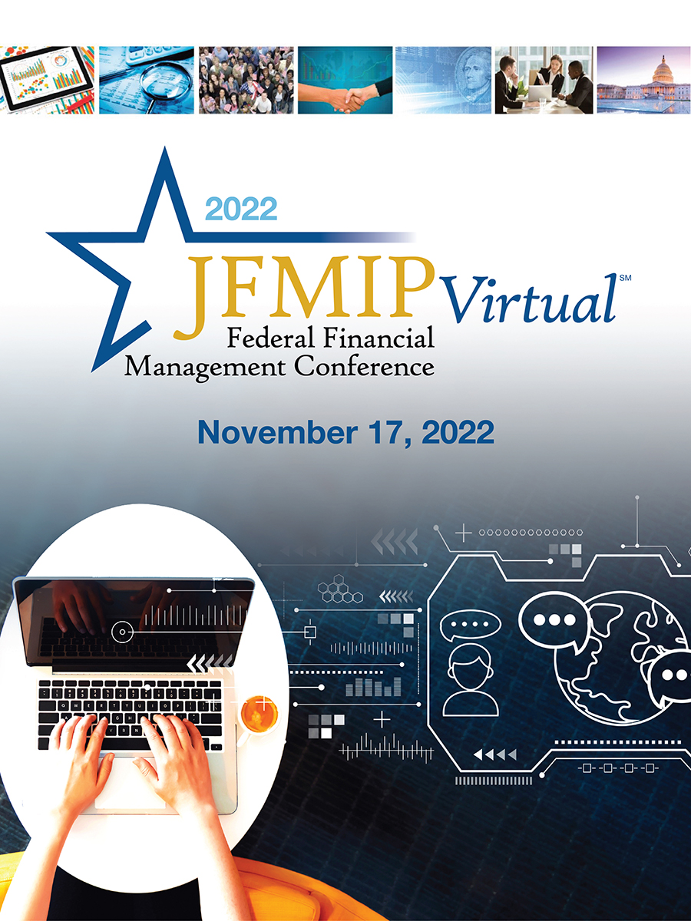

**WELCOME TO THE**

**2022 JFMIP*Virtual****SM*

Welcome to the 2022 JFMIP*VirtualSM*. This cooperative undertaking between Treasury, Government Accountability Office (GAO), Office of Management and Budget (OMB), and Office of Personnel Management (OPM), provides up to 4.5 continuing professional education (CPE) credits. All educational sessions will be led by federal financial management experts and select business partners.

The JFMIP*VirtualSM* will take place on November 17, 2022 between 9:00 – 4:15 PM EST. We look forward to your participation. For conference and training details, visit www.fiscal.treasury.gov.

CPEs will be provided by Treasury’s Bureau of the Fiscal Service (Fiscal Service). Fiscal Service is registered with the National Association of State Boards of Accountancy (NASBA) as a sponsor of continuing professional education on the National Registry of CPE Sponsors. State boards of accountancy have final authority on the acceptance of the individual courses of CPE credit. Complaints regarding registered sponsors may be submitted to the National Registry of CPE sponsors through this website: [www.nasbaregistry.org](http://www.nasbaregistry.org).

**CONFERENCE PROGRAM CONTENTS**

Conference Schedule Grid / Thursday November 17…….……………………………………………………………………. Page 2

Session Descriptions…………………………………………………………………………………………………………………….………Page 3

Conference details……………………………………………………………………………………………………….………………………Page 6

**2022 JFMIP*Virtual****SM* **Schedule: November 17, 2022**

|  |  |  |  |
| --- | --- | --- | --- |
| **Time** | **Event** | **CPEs** | **Minutes** |
| **9:00 AM –**  **10:15 AM** | **JFMIP Principals Roundtable** | 0 | 75 |
| **10:15 AM –**  **10:25 AM** | **Scantlebury Award Presentation** | 0 | 10 |
| **10:25 AM –**  **10:40 AM** | **15-minute Break** | 0 | 15 |
| **10:40 AM –**  **11:55 AM** | **Payment Integrity: Tools and Key Practices to Reduce Improper Payments Through Identity Verification** | 1.5 | 75 |
| **11:55 AM –**  **1:30 PM** | **Lunch Break** | 0 | 95 |
| **1:30 PM -2:45 PM** | **The Future of the Workforce** | 1.5 | 75 |
| **2:45 PM – 3:00 PM** | **15-minute Break** | 0 | 15 |
| **3:00 PM – 4:15 PM** | **The JFMIP Blockchain Initiative** | 1.5 | 75 |

**Session Descriptions**

###### JFMIP Principals Roundtable / Scantlebury Award

##### Thursday, November 17: 09:00 to 10:25 A.M.

**Program Description**: The JFMIP Principals work in cooperation with each other and with operating agencies to improve and coordinate financial management policies and practices throughout the government. The JFMIP Principals are the Comptroller General of the United States, the Director for Management of OMB, Secretary of the Treasury, and the Director of OPM. In this session, the Principals or their representatives will discuss with the audience important federal financial management topics.

###### Learning Objectives: Session participants will hear information on a variety of topics that will provide them with an understanding of recent events and emerging trends relevant to federal financial management.

###### CPE Credit: No CPEs will be granted for this session

###### Prerequisites and Advance Preparation: None

###### Field of Study: FIN (Finance)

###### Program Level: CPEs will not be provided for this session

###### Speakers:

###### *Gene Dodaro, Comptroller of the United States, Government Accountability Office*

###### *Dave Lebryk, Fiscal Assistant Secretary, Department of the Treasury*

###### *Deidre Harrison, Acting Controller, Office of Management and Budget*

###### *David Padrino, Chief Transformation Officer, Office of Personnel Management*

###### *Beryl Davis, Managing Director, Financial Management and Assurance, Government Accountability Office*

##### **Payment Integrity: Tools and Key Practices to Reduce Improper Payments through Identity Verification**

##### Thursday, November 17: 10:40 to 11:55 A.M.

##### 

**Program Description:** The federal government spends trillions of dollars each year addressing public needs while ensuring that the right recipient receives the right amount when it makes payments to or on behalf of individuals and businesses. Federal agencies and oversight bodies have recently taken steps to determine the significance of misrepresented identity as a cause of improper payments and have begun to focus on identity verification as a means to improve payment integrity. Discussion topics for this session will include 1) key considerations in effective identity verification for federal agencies to improve payment integrity, 2) government-wide considerations for facilitating effective identity verification, and 3) key practices in using historical data to identify potential improper payments. Participants will also receive a demonstration of the simulation tool and a walkthrough of how to access the report and simulation tool from the JFMIP webpage.

###### Learning Objectives: Session participants will learn about (1) key considerations in effective identity verification for federal agencies to improve payment integrity, (2) government-wide considerations for facilitating effective identity verification, and (3) key practices in using historical data to identify potential improper payments.

###### CPE Credit: 1.5 CPE will be granted for this session

###### Prerequisites and Advance Preparation: None

###### Field of Study: FINT (Finance-Technical)

###### Program Level: Basic

###### Speakers:

###### *Marshall Henry, Director, Do Not Pay Business Center, Bureau of the Fiscal Service (Moderator)*

###### *Andrew Kurtzman, Assistant Director of Innovation Lab, Science, Technology, Assessment, and Analytics Team, Government Accountability Office*

###### *Kevin McDaniels, Senior Advisor, Payment Integrity Center of Excellence, Bureau of the Fiscal Service*

###### *Heather Pajak, Senior Policy Analyst, Office of Federal Financial Management, Office of Management and Budget*

###### *Andrea Wood, Senior Advisor, Executive Councils Team, General Services Administration*

##### **The Future of the Workforce**

##### Thursday, November 17: 1:30 to 2:45 p.m.

**Program Description**: The Federal Government has largely transitioned to a hybrid work construct at most federal agencies. Implementation across agencies is by design, not uniform, but inspired by the diverse mission set and employee make-up of each agency. Throughout this transition, OPM has lead efforts by producing tools, issuing guidance, conducting technical assistance, and aiding agencies through this uncertain time. OPM will provide a summary of the progress to date and some of the future planned initiatives that ensure a leadership role not only in the US, but across the globe.

During the pandemic, the Chief Financial Officers Council continued to advance their “Shape the Workforce Initiative” which culminated in a visionary document that defined seven strategic goals for the Financial Management (FM workforce). Throughout the transition to hybrid work, the Office of Management and Budget (OMB) chartered the Executive Steering Committee (ESC) to advance the vision of work. The ESC lead will provide an update on progress and detail how the initiatives are strategically positioning the current and future FM workforce for success.

###### Learning Objectives: Participants will learn how OPM is shaping the future of work, thinking differently about future challenges, and anticipating disruptions to ensure a resilient government capable of functioning for all Americans regardless of circumstances. Participants will gather insights on some of the major initiatives currently underway and what is planned. In addition, participants will learn how the CFOC turned strategy and vision into action and what progress they have made in advancing their long-term strategy.

###### CPE Credit: 1.5 CPE will be granted for this session

###### Prerequisites and Advance Preparation: None

###### Field of Study: BMO (Business Management & Organization)

###### Program Level: Basic

###### Speakers:

###### *Eric Popiel, Strategic Workforce Team Manager, Office of Personnel Management*

###### *Jason Barke, Deputy Associate Director for Employee Services at the Office of Personnel Management*

###### *Steve Kunze, Deputy CFO and Director for Financial Management, Department of Commerce*

###### *Peter Bonner, Associate Director, Human Resource Solutions, Office of Personnel Management*

###### JFMIP Blockchain Initiative

##### Thursday, November 17: 3:00 to 4:15 p.m.

###### Program Description: Distributed ledger technologies have enabled the private sector to improve the visibility and reliability of data. As distributed ledger technologies like blockchain migrate to federal agencies, understanding their potential impacts to the federal financial management and oversight community is more important than ever.

###### The JFMIP is currently undertaking the Blockchain Initiative which is focused on non-cryptocurrency applications of blockchain technology in the federal government. This session will discuss the ongoing initiative, which aims to deploy an interagency blockchain solution for grant payments and provide a set of key blockchain considerations for agencies related to financial management and oversight. This session will cover some of the key topics that will be published in the JFMIP Blockchain Initiative’s upcoming product and will also go over the prototyped interagency blockchain and its potential impacts to grant payments and related processes. This session will also provide some key points to consider within your agencies concerning distributed ledger technologies in a rapidly evolving digital world.

###### Learning Objectives: Participants will learn from a panel on scaling a blockchain across agency boundaries and the impacts of blockchain to financial management and oversight, which could be applicable at the U.S. federal, state, and local levels.

###### CPE Credit: 1.5 CPE will be granted for this session

###### Prerequisites and Advance Preparation: None

###### Field of Study: FINT (Finance-Technical)

###### Program Level: Basic

###### Speakers:

###### *Tim Persons, Ph.D., Chief Scientist and Managing Director, Science, Technology Assessment, and Analytics Team, Government Accountability Office (Moderator)*

###### *Martin Skorczynski, Assistant Director, Science, Technology Assessment, and Analytics Team, Government Accountability Office*

###### *Dave Jones, Digital Service Expert, Office of Personnel Management*

*Tammie Johnson, Management and Program Analyst, Office of Financial Innovation and Transformation, Bureau of the Fiscal Service*

**CONFERENCE DETAILS**

**PROGRAM REGISTRATION REQUIREMENTS**

Registration is performed via the registration page, which is located at: <https://cvent.me/rDBvD0>

**INSTRUCTIONAL DELIVERY METHOD**

All sessions will be delivered as “Group Internet based”.

Session Descriptions, Learning Objectives, Prerequisites, Advance Preparation requirements, and Fields of Study for event sessions are listed on pages 3-5.

2022 JFMIP*VirtualSM* sessions require “Basic” program knowledge. Prerequisites are not required to attend.

**VIRTUAL ATTENDANCE MONITORING POLICY AND CPE CREDITS**

CPE credits will only be granted if you participate in the entire virtual event. Participation is confirmed by responding to at least 3 polling questions per session. These questions will appear as a pop-up window or questionnaire at random intervals.

**IMPORTANT**: Attendees who view these sessions at a later time will not qualify for CPE credits.

**COMPLAINT RESOLUTION, CANCELATION, & REFUND POLICIES**

For more information regarding administrative policies or to file a complaint, please contact us at Agency.Outreach@fiscal.treasury.gov.

Attendees may cancel at any time. To do so, please contact Agency.Outreach@fiscal.treasury.gov.

The 2022 JFMIP*VirtualSM* is a free event; no refunds will be necessary.

**NASBA SPONSORSHIP STATEMENT**

Registered attendees have the opportunity to earn up to 4.5 continuing professional education (CPE) credits for participation in the conference. Each session is worth one CPE credit.

A CPE certificate will be sent to your email address by early-January 2023, verifying your attendance at the conference. Please contact Agency.Outreach@fiscal.treasury.gov if you do not receive your certificate by January 14th.



The Bureau of the Fiscal Service is registered with the National Association of State Boards of Accountancy (NASBA) as a sponsor of continuing professional education on the National Registry of CPE Sponsors. State boards of accountancy have final authority on the acceptance of individual courses for CPE credit. Complaints regarding registered sponsors may be submitted to the National Registry of CPE Sponsors through its website: www.nasbaregistry.org.

**CONFERENCE EVALUATION**

You will receive an online survey at the end of conference session.

**SESSION PRESENTATIONS**

Select educational session presentations will be posted for your reference until February 25, 2022. The posting location will be sent to registered attendees following the conference.

***ACKNOWLEDGEMENTS***

*We thank conference presenters for informative sessions, conference attendees for asking important questions, and conference panel members for providing knowledgeable answers.*

*We also are grateful for conference volunteers who gave helpful assistance, registration staff who welcomed attendees, and the conference coordination team who organized all the details.*

*Thanks for attending the 2022 JFMIPVirtualSM. The Treasury, GAO, OMB, and OPM staff look forward to working together with you in the coming year as we launch into a new era of government financial management.*