XML Schema 5.0.1 Download Instructions

To download the current version of the XML Schema version 5.0.1, go to the Bureau of the Fiscal Service website, using this link: https://www.fiscal.treasury.gov/data/

You will then see this page:

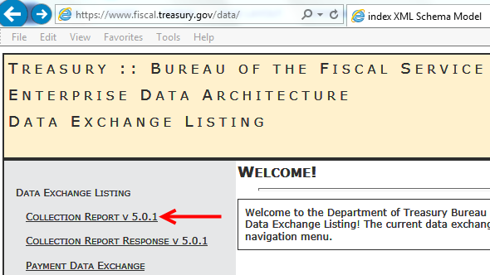

- Click the link for "Collection Report v 5.0.1" on the left side of the screen.
This will open up a new page with more options.

On the lower part of the page,
- Expand the link titled "Published Releases" to display the current release.
- Click the link for "Current 5.0.1 Release", which will then make a zip file containing the current XML 5.0.1 release available.
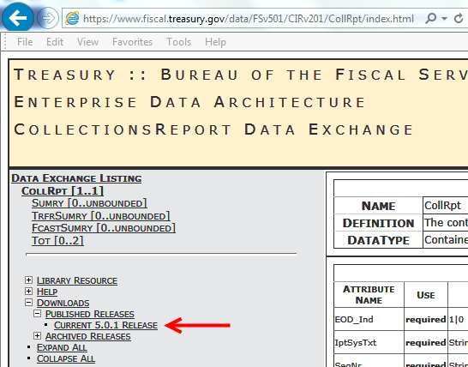

You will then be prompted to open or save the FiscalService_Schema_v5.0.1.zip file.

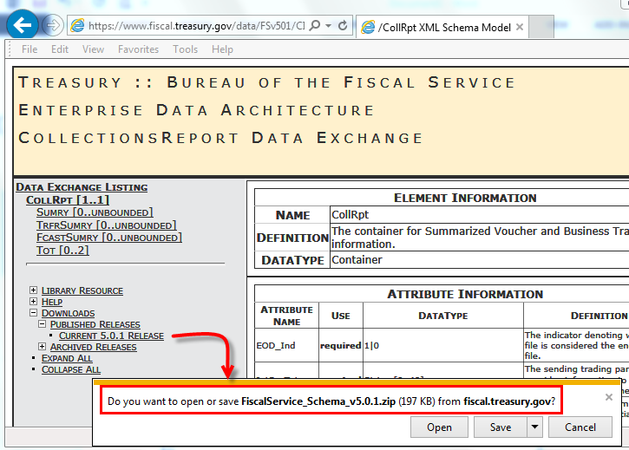

Replace all local files in your system for 5.0.1 with the files contained in the newly downloaded zip.

