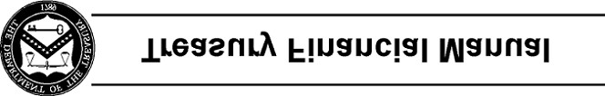
Part 1, Section VI: USSGL Crosswalks to Reclassified
Statements
This section includes crosswalks for use in Fiscal Year 2019 GTAS Reporting. These crosswalks map
USSGL accounts to external reports in accordance with TFM Volume I, Part 2, Chapter 4700, Federal Entity Reporting Requirements for the Financial Report of the United States Government. Each report crosswalk lists the proper USSGL accounts and applicable attributes for each line and/or column on the reports. Attributes identify information subsidiary to the basic 6-digit USSGL accounts. This subsidiary information is necessary to meet external reporting requirements. See Section IV for additional information on attributes.
The following are crosswalks from the USSGL Chart of Accounts to standard external reports required by Fiscal Service:
Section VI Page Number
USSGL Crosswalk Reclassified Balance Sheet (RBS) VI RBS - 1
USSGL Crosswalk Reclassified Statement of Net Cost (RSNC) VI RSNC - 1
USSGL Crosswalk Reclassified Statement of Operations and Changes VI RSOCNP - 1 in Net Position (RSOCNP) Page 1 of 1

