USSGL Board Member Survey

- Are there existing TFM Sections that you’d like to see in a different file format to facilitate agency accounting systems or other needs? (i.e. Excel, Access, web-based)

- Are there current TFM Sections that your agency does not use/does not find useful?

- Is there USSGL, Financial Statement, or GTAS data on which your agency depends, but is not currently available in the USSGL TFM Supplement, or your agency must manually adjust to fit its needs?

- Do you have any concerns with the display and/or usefulness of the USSGL TFM Supplement website?

- Do you feel the combined file within the TFM supplement is useful?

Part 1 Fiscal Year 2024 Reporting | TFX: Treasury Financial Experience

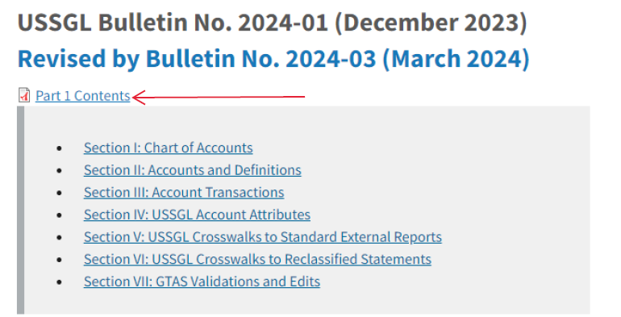

- Do you feel the Transactions Listing within Section III of the TFM is useful?

Part 1 Fiscal Year 2024 Reporting | TFX: Treasury Financial Experience

