APPROPRIATIONS PROVIDED BY A CONTINUING RESOLUTION

EFFECTIVE FISCAL 2020

PREPARED BY:

GENERAL LEDGER AND ADVISORY BRANCH
FISCAL ACCOUNTING OPERATIONS
BUREAU OF THE FISCAL SERVICE
U.S. DEPARTMENT OF THE TREASURY

Version  Number | Date | Description of Change | Effective USSGL TFM
1.0 | 10/2005 | Original | TFM Release S2-05-03
2.0 | 02/2020 | Updated USSGL accounts to 6 digit and financial statements and references to be in line with current guidance. | TFM Bulletin No. 2020-08
Continuing resolutions (CRs) are joint resolutions (passed by the House and the Senate and signed by the President) that provide continuing appropriations for part of a fiscal year (short term) or for a full fiscal year. Continuing resolutions are enacted when Congress has not yet passed one or more appropriations bills for a fiscal year or when the President has vetoed congressionally passed appropriations bills. Lacking appropriations, most programs can not incur new obligations.

Continuing Resolutions usually do not appropriate specific sums of money. Instead the CR usually provides “formulas” for calculating the amounts available for continuing projects or activities (rate for operations). This formula is applied by OMB in apportioning funds provided by the CR.

After a short-term CR is enacted into law, the Office of Management and Budget will issue a bulletin to automatically apportion funds under the CR as provided by the appropriated “rate of operations”, which is the annualized level this is available through the period covered CR. This automatic apportionment applies in most accounts, but not all. For particular accounts, OMB may require a separate account-specific apportionment.

Warrants are not issued until Congress enacts the regular appropriation bill, unless agencies are under a long-term CR. Exceptions may be made for issuing warrants under a CR:

- If the CR covers specific mandatory federal payments, or
- When the CR covers the entire year.

Although a warrant may not be issued, agencies’ Fund Balance With Treasury (FBWT) should be recorded under a CR. The CR entitles agencies to FBWT. SFFAS No. 7, Accounting for Revenue and Other Financing Sources and Concepts for Reconciling Budgetary and Financial Accounting, paragraph 71 states that appropriations should be recognized in capital as “unexpended appropriations” (and among assets as “funds with Treasury”) when made available for apportionment, even if a Treasury Warrant has not yet been received, or the amount has not been fully apportioned.

Furthermore, until Fiscal Service processes a warrant, agencies’ FBWT will not be posted to its Central Accounting System. The balance in this account will not match CARS. However, agencies will post its normal receipt and disbursement activity using USSGL Account 101000, which should match the balance in CARS.

This scenario illustrates accounting transactions and reporting requirements agencies should use to record FBWT while under a CR.

Current USSGL accounts:
Account Title: Appropriated Dedicated Collections Receivable
Account Number: 139000
Normal Balance: Debit
Definition: The amount due from unavailable receipt account for funding provided under a continuing resolution and apportioned in accordance with Office of Management and Budget's automatic apportionment bulletin. Pursuant to a continuing resolution or enacted annual appropriation act, the account may be used while awaiting a warrant to be issued for an appropriation derived from an unavailable special or trust non-revolving receipt account by the U.S. Department of the Treasury's Bureau of the Fiscal Service. The balance in this account will adjust to zero when the U.S. Department of the Treasury's Bureau of Fiscal Service issues a warrant and must adjust to zero by yearend. This account does not close at yearend.
Justification: To separately track funds to be appropriated from an unavailable special or trust non-revolving receipt account during a continuing resolution while awaiting the issuance of the warrant by Treasury’s Bureau of the Fiscal Service.

Account Title: Other Liabilities Without Related Budgetary Obligations
Account Number: 299000
Normal Balance: Credit
Definition: Other liabilities not otherwise classified, for which there is not a related budgetary obligation. This account does not close at yearend.
Justification: To separate warrant activity.
Account Title: Other Liabilities – Reductions
Account Number: 299100
Normal Balance: Credit
Definition: Other liabilities of reductions where there is not a related budgetary obligation. Use while awaiting a warrant to be issued for a reduction (i.e., rescission, across-the-board reduction, and sequestration). The warrant must be issued by yearend. This account does not close at yearend.
Justification: To separate warrant activity.

Account Title: Appropriated Dedicated Collections Liability
Account Number: 299200
Normal Balance: Debit
Definition: The amount due to the expenditure treasury account symbol from unavailable receipt account for funding provided under a continuing resolution and apportioned in accordance with Office of Management and Budget's automatic apportionment bulletin. Pursuant to a continuing resolution or enacted annual appropriation act, the account may be used while awaiting a warrant to be issued for an appropriation derived from an unavailable special or trust non-revolving receipt account by the U. S. Department of the Treasury's Bureau of the Fiscal Service. The balance in this account will adjust to zero when the U.S. Department of the Treasury's Bureau of Fiscal Service issues a warrant and must adjust to zero by yearend. This account does not close at yearend.
Justification: To separately track appropriated dedicated collections during a continuing resolution or while waiting the issuance of a warrant from an unavailable special or trust non-revolving receipt account by Treasury’s Bureau of the Fiscal Service.
Account Title: Unexpended Appropriations While Awaiting a Warrant
Account Number: 309000
Normal Balance: Credit
Definition: The amount of new appropriations expected to be received during the fiscal year from the General Fund of the U.S. Government. This is equal to the funding provided under a continuing resolution and apportioned in accordance with Office of Management and Budget's automatic apportionment bulletin. Pursuant to a continuing resolution or enacted annual appropriation act, the account may be used while awaiting a warrant to be issued for an appropriation by the U.S. Department of the Treasury's Bureau of the Fiscal Service. Special and trust funds do not use this USSGL account to record appropriations for dedicated collections. However, special and trust funds that receive appropriations from the General Fund of the U.S. Government are to use this account. The balance in this account will adjust to zero when the U.S. Department of the Treasury's Bureau of the Fiscal Service issues a warrant and must adjust to zero by yearend. This account does not close at yearend.
Justification: To separate appropriations while awaiting the issuance of a warrant by Treasury’s Bureau of the Fiscal Service from appropriations received
Account Title: Appropriations Outstanding – Warrants to be Issued
Account Number: 309010
Normal Balance: Credit
Definition: The amount recorded by the General Fund of the U.S. Government for new appropriations expected to be issued during the fiscal year. This is equal to the funding provided under a continuing resolution and apportioned in accordance with Office of Management and Budget's automatic apportionment bulletin. Pursuant to a continuing resolution or enacted annual appropriation act, the account may be used while awaiting a warrant to be issued for an appropriation by the U.S. Department of the Treasury's Bureau of the Fiscal Service. This account corresponds to the Unexpended Appropriations While Awaiting a Warrant. The balance in this account will adjust to zero when the U.S. Department of the Treasury's Bureau of the Fiscal Service issues a warrant and must adjust to zero by yearend. This account does not close at yearend.
Justification: To separate appropriations while awaiting the issuance of a warrant by Treasury’s Bureau of the Fiscal Service from appropriations received.
Account Title: Appropriated Dedicated Collections to be Transferred In
Account Number: 573500
Normal Balance: Credit
Definition: The amount to be appropriated to the expenditure account of dedicated collections, via warrant, from an unavailable receipt account. This is equal to the funding provided under a continuing resolution and apportioned in accordance with Office of Management and Budget's automatic apportionment bulletin. Pursuant to a continuing resolution or enacted annual appropriation act, the account may be used while awaiting a warrant from the unavailable receipt account. This account may be used while waiting a warrant for reductions from the expenditure TAS to the unavailable receipt account. The balance in this account will adjust to zero when the U.S. Department of the Treasury's Bureau of the Fiscal Service issues a warrant and must adjust to zero by yearend. This account does not close at yearend.
Justification: To record appropriations during a continuing resolution from dedicated collections while awaiting the transfer in to be processed.

Account Title: Appropriated Dedicated Collections to be Transferred Out
Account Number: 573600
Normal Balance: Debit
Definition: The amount to be appropriated from an unavailable receipt account to the expenditure account of dedicated collection, via warrant. This is equal to the funding provided under a continuing resolution and apportioned in accordance with Office of Management and Budget's automatic apportionment bulletin. Pursuant to a continuing resolution or enacted annual appropriation act, the account may be used while awaiting a warrant from the unavailable receipt account. This account may be used while waiting a warrant for reductions from the expenditure TAS to the unavailable receipt account. The balance in this account will adjust to zero when the U.S. Department of the Treasury's Bureau of the Fiscal Service issues a warrant and must adjust to zero by yearend. This account does not close at yearend.
Justification: To record appropriations during a continuing resolution from dedicated collections while awaiting the transfer out to be processed.

This scenario presents the first and second quarters of a fiscal year. During the first quarter, the agency is notified that its appropriations bill has not been signed and the agency is under a continuing resolution. In quarter two, the agency’s appropriation bill has been signed. Two separate situations are presented in quarter two, which are as follows:

Situation 1: General Fund Expenditure TAFS receives exact amount in the appropriation.
Situation 2: Special Fund Expenditure TAFS receives exact amount in the appropriation.

The following quarterly statements are presented: SF 133, Report on Budget Execution and Budgetary Resources, Consolidated Balance Sheet, Consolidated Statement of Net Cost and Consolidated Statement of Changes in Net Position. The statements are based on fiscal year 2020 crosswalks.

QTR 1 Situation 1

1A & B. To record an agencies’ Fund Balance With Treasury under a continuing resolution as determined by OMB’s automatic apportionment bulletin. No warrants processed.
1A To record the Fund Balance With Treasury under a continuing resolution.
QTR 1 | FPA (F 1XX) |  | The General Fund (G 099)
 | Debit | Credit | Debit | Credit | TC
Budgetary Entry  411900 Other Appropriations Realized  445000 Unapportioned Authority  Proprietary Entry  109000 (G) Fund Balance With Treasury While Awaiting a Warrant  (RC 40)  309000 (G) Unexpended Appropriations While Awaiting  a Warrant (RC 41)  309010 (F) Appropriations – Warrants to be Issued (RC 41)  209010 (F) Liability for Fund Balance While Awaiting a Warrant (RC 40) | 100,000  24,953 | 100,000  24,953 | 24,953 | 24,953 | A196  A197

1B. To record authority temporarily unavailable pursuant to public law.
QTR 1 | FPA (F 1XX) |  | The General Fund (G 099)
 | Debit | Credit | Debit | Credit | TC
Budgetary Entry  445000 Unapportioned Authority  439500 Authority Unavailable Pursuant to Public Law  Proprietary Entry  None | 75,047 | 75,047 | N/A | N/A | A128

1C. To record budgetary authority automatically apportioned by OMB and available for allotment.
QTR 1 | FPA (F 1XX) |  | The General Fund (G 099)
 | Debit | Credit | Debit | Credit | TC
Budgetary Entry  445000 Unapportioned Authority  451000 Apportionments  Proprietary Entry  None | 24,953 | 24,953 | N/A | N/A | A116

*Transactions 1A, 1B, and 1C should occur simultaneously.

- To record allotment of authority.
QTR 1 | FPA (F 1XX) |  | The General Fund (G 099)
 | Debit | Credit | Debit | Credit | TC
Budgetary Entry  451000 Apportionments  461000 Allotments – Realized Resources  Proprietary Entry  None | 24,953 | 24,953 | N/A | N/A | A120

- Purchase request for $4,000, was approved. (Commitment)
QTR 1 | FPA (F 1XX) |  | The General Fund (G 099)
 | Debit | Credit | Debit | Credit | TC
Budgetary Entry  461000 Allotments – Realized Resources  470000 Commitments  Proprietary Entry  None | 4,000 | 4,000 | N/A | N/A | B202

- To record current-year undelivered orders without an advance.
QTR 1 | FPA (F 1XX) |  | The General Fund (G 099)
 | Debit | Credit | Debit | Credit | TC
Budgetary Entry  470000 Commitments  480100 Undelivered Orders Obligations – Unpaid  Proprietary Entry  None | 4,000 | 4,000 | N/A | N/A | B204

- To record the delivery of goods and accrue a liability.
QTR 1 | FPA (F 1XX) |  | The General Fund (G 099)
 | Debit | Credit | Debit | Credit | TC
Budgetary Entry  480100 Undelivered Orders Obligations – Unpaid  490100 Delivered Orders – Obligations, Unpaid  Proprietary Entry  610000 (N) Operating Expenses  211000 N Accounts Payable  310700 (G) Unexpended Appropriations Used (RC 39)  570000 (G) Expended Appropriations (RC 38)  570005 (F) Appropriations Expended (RC 38)  320700 (F) Appropriations Outstanding – Used (RC 39) | 4,000  4,000  4,000 | 4,000  4,000  4,000 | 4,000 | 4,000 | B302  B134

- Payment schedule certified and confirmed.
QTR 1 | FPA (F 1XX) |  | The General Fund (G 099)
 | Debit | Credit | Debit | Credit | TC
Budgetary Entry  490100 Delivered Orders – Obligations – Unpaid  490200 Delivered Orders- Obligations, Paid  Proprietary Entry  211000 (N) Accounts Payable  101000 (G) Fund Balance with Treasury (RC 40)  201000 (F) Liability for Fund Balance With Treasury (RC 40)  198000 (F) Asset for Agency’s Custodial and Non-entity Liabilities (RC 46) | 4,000  4,000 | 4,000  4,000 | 4,000 | 4,000 | B110

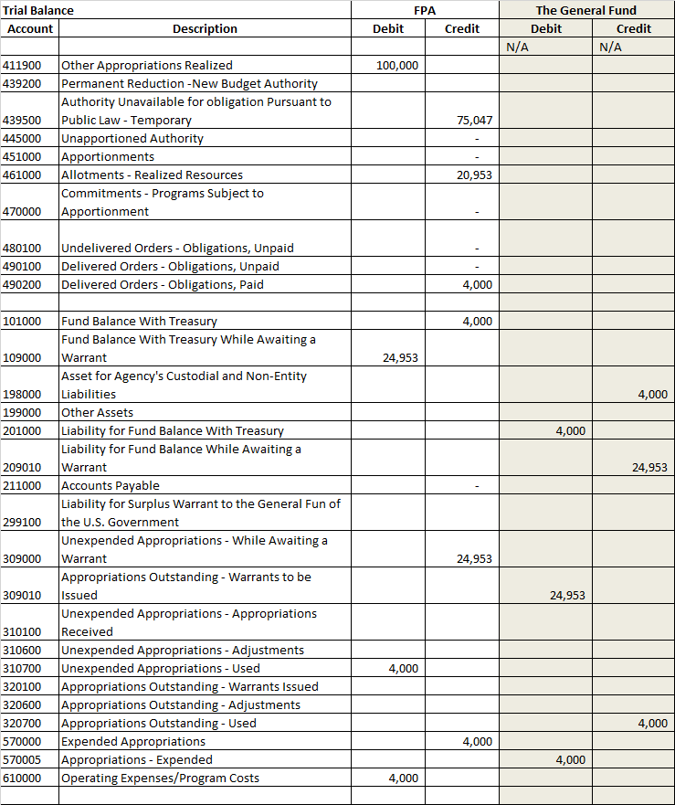

Note, no statements are illustrated in this scenario for period 03.

QTR 2 Situation 1

The CR, passed in Quarter 1 has expired and the agency has received notification that the CR has been extended for an additional 30 days. The amount available for obligation under the extension is $8,408. The annualized level of the appropriation provided under the CR is unchanged.

To record additional Fund Balance With Treasury under a continuing resolution and record authority previously temporarily unavailable as available.
QTR 2 | FPA (F 1XX) |  | The General Fund (G 099)
 | Debit | Credit | Debit | Credit | TC
Budgetary Entry  439500 Authority Unavailable Pursuant to Public – Temporary – Current-Year Authority  445000 Unapportioned Authority  Proprietary Entry  109000 (G) Fund Balance With Treasury While  Awaiting a Warrant (RC 40)  309000 (G) Unexpended Appropriations – While Awaiting a Warrant (RC 41)  309010 (F) Appropriations Outstanding – Warrants to be Issued (RC 41)  209010 F1XX Liability for Fund Balance While Awaiting a  Warrant (RC 40) | 8,408  8,408 | 8,408  8,408 | 8,408 | 8,408 | A128R  A197

- To record budgetary authority apportioned by OMB and available for allotment.
QTR 2 | FPA (F 1XX) |  | The General Fund (G 099)
 | Debit | Credit | Debit | Credit | TC
Budgetary Entry  445000 Unapportioned Authority  451000 Apportionments  Proprietary Entry  None | 8,408 | 8,408 | N/A | N/A | A116

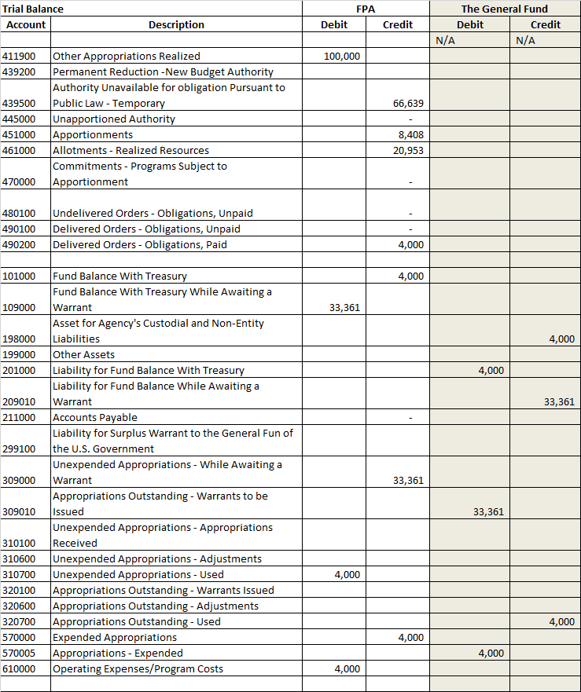
Note, no statements are illustrated in this scenario for period 04.
QTR 2 Period 05 (Situation 1)
1 A & B Congress enacted the appropriation bill for $100,000 and a $1,000 reduction.

1A. To record receipt of authority (warrant Not received) and record authority previously temporarily unavailable as available.
QTR 2 (Situation 1) | FPA (F 1XX) |  | The General Fund (G 099)
 | Debit | Credit | Debit | Credit | TC
Budgetary Entry  439500 Authority Unavailable Pursuant to Public  445000 Unapportioned Authority  Proprietary Entry  109000 (G) Fund Balance With Treasury While Awaiting a Warrant  (RC 40)  309000 (G) Unexpended Appropriations While Awaiting a Warrant (RC 41)  309010 (F) Appropriations – Warrants to be Issued (RC 41)  209010 (F) Liability for Fund Balance While Awaiting a Warrant (RC 40) | 66,639  66,639 | 66,639  66,639 | 66,639 | 66,639 | A128R  A197

1B. To record 1,000 permanent reduction of unexpended appropriations (warrant Not received).
QTR 2 (Situation 1) | FPA (F 1XX) |  | The General Fund (G 099)
 | Debit | Credit | Debit | Credit | TC
Budgetary Entry  445000 Unapportioned Authority  439200 Permanent Reduction – New Budget Authority  Proprietary Entry  310600 (G) Unexpended Appropriation – Adjustments (RC 41)  299100 (G) Liability for Surplus Warrant to the General Fund  of the U.S. Government (RC 30)  199000 (F) Other Assets (RC 30)  320600 (F) Appropriations Outstanding - Adjustments (RC 41) | 1,000  1,000 | 1,000  1,000 | 1,000 | 1,000 | A132

- To record budgetary authority apportioned by OMB and available for allotment.
QTR 2 (Situation1) | FPA (F 1XX) |  | The General Fund (G 099)
 | Debit | Credit | Debit | Credit | TC
Budgetary Entry  445000 Unapportioned Authority  451000 Apportionments  Proprietary Entry  None | 65,639 | 65,639 | N/A | N/A | A116

- To record allotment of authority.
QTR 2 (Situation1) | FPA (F 1XX) |  | The General Fund (G 099)
 | Debit | Credit | Debit | Credit | TC
Budgetary Entry  451000 Apportionments  461000 Allotments – Realized Resources  Proprietary Entry  None | 74,047 | 74,047 | N/A | N/A | A120

Trial Balance |  | FPA |  | The General Fund
Account | Description | Debit | Credit | Debit | Credit
411900 | Other Appropriations - Realized | 100,000
439200 | Permanent Reduction - New Budget Authority |  | 1,000
439500 | Authority Unavailable for Obligation Pursuant to Public Law - Temporary
445000 | Unapportioned Authority
451000 | Apportionments
461000 | Allotments - Realized Resources |  | 95,000
470000 | Commitments - Programs Subject to Apportionment
480100 | Undelivered Orders - Obligations, Unpaid
490100 | Delivered Orders - Obligations, Unpaid
490200 | Delivered Orders - Obligations, Paid |  | 4,000
101000 | Fund Balance With Treasury |  | 4,000
109000 | Fund Balance With Treasury While Awaiting a Warrant | 100,000
198000 | Asset for Agency's Custodial and Non-Entity Liabilities |  |  |  | 4,000
199000 | Other Assets |  |  | 1,000
201000 | Liability for Fund Balance With Treasury |  |  | 4,000
209010 | Liability for Fund Balance While Awaiting a Warrant |  |  |  | 100,000
211000 | Accounts Payable
299100 | Liability for Surplus Warrant to the General Fund of the U.S. Government |  | 1,000
309000 | Unexpended Appropriations - While Awaiting a Warrant |  | 100,000
309010 | Appropriations Outstanding - Warrants to be Issued |  |  | 100,000
310100 | Unexpended Appropriations - Appropriations Received
310600 | Unexpended Appropriations - Adjustments | 1,000
310700 | Unexpended Appropriations - Used | 4,000
320100 | Appropriations Outstanding - Warrants Issued
320600 | Appropriations Outstanding - Adjustments |  |  |  | 1,000
320700 | Appropriations Outstanding - Used |  |  |  | 4,000
570000 | Expended Appropriations |  | 4,000
570005 | Appropriations - Expended |  |  | 4,000
610000 | Operating Expenses/Program Costs | 4,000
Note, no statements are illustrated in this scenario for period 05.

Note, no statements are illustrated in this scenario for period 05.

QTR 2 Period 06 (Situation 1)

To record the enactment of the appropriation via the approval and processing of the appropriation warrant by Treasury.
QTR 2 (Situation 1) | FPA (F 1XX) |  | The General Fund (G 099)
 | Debit | Credit | Debit | Credit | TC
Budgetary Entry  None  Proprietary Entry  309000 (G) Unexpended Appropriations – While Awaiting a Warrant  (RC 41)  109000 (G) Fund Balance With Treasury While Awaiting a Warrant (RC 40)  101000 (G) Fund Balance With Treasury (RC 40)  310100 (G) Unexpended Appropriations – Appropriations Received (RC 41)  320100 (F) Appropriations – Warrants Issued (RC 41)  201000 (F) Liability for Fund Balance With Treasury (RC 40)  209010 (F) Liability for Fund Balance While Awaiting a Warrant (RC 40)  309010 (F) Appropriations – Warrants to be Issued (RC 41) | 100,000  100,000 | 100,000  100,000 | 100,000  100,000 | 100,000  100,000 | A128R

To record a permanent reduction of unexpended appropriations via the approval and processing of a negative warrant by Treasury.
QTR 2 (Situation 1) | FPA (F 1XX) |  | The General Fund (G 099)
 | Debit | Credit | Debit | Credit | TC
Budgetary Entry  None  Proprietary Entry  299100 (G) Liability for Surplus Warrant to the General Fund of the U.S. Government (RC 30)  101000 (G) Fund Balance With Treasury (RC 40)  201000 (F) Liability for Fund Balance With Treasury (RC 40)  320600 (F) Appropriations Outstanding – Adjustments (RC 41)  320600 (F) Appropriations Outstanding – Adjustments (RC 41)  199000 (F) Other Assets (RC 30) | 1,000 | 1,000 | 1,000  1,000 | 1,000  1,000 | A132R

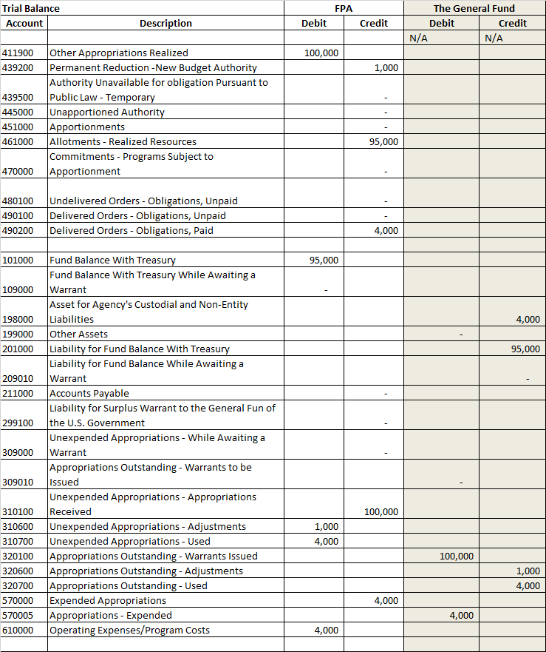
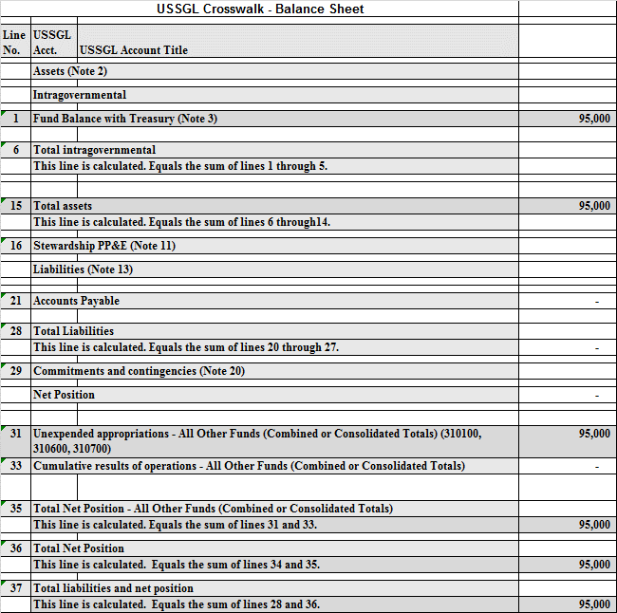
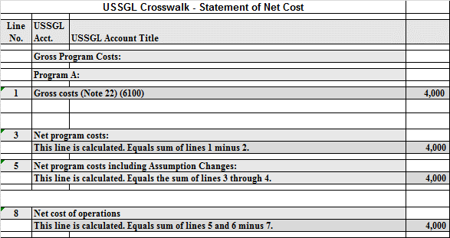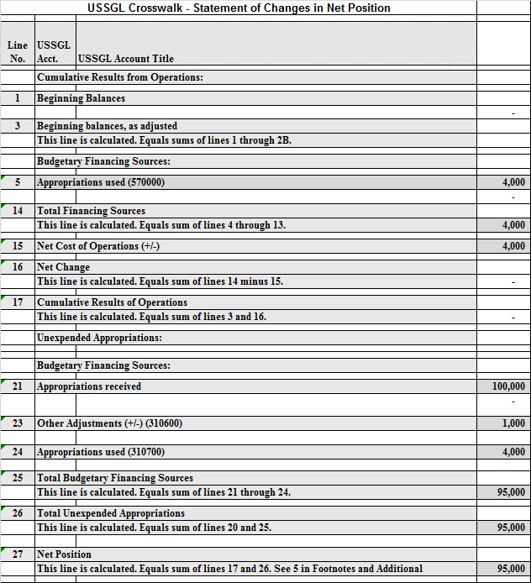

STATEMENT OF BUDGETARY RESOURCES
Line No. | Budgetary resources:
1290 | Appropriations (discretionary and mandatory) (411900, 439200) | 99,000
1910 | Total budgetary resources (calc.) | 99,000
 | Status of budgetary resources:
2190 | New obligations and upward adjustments (total) (Note 31) (490200) | 4,000
2204 | Apportioned, unexpired account (461000) | 95,000
2490 | Unobligated balance, end of year (total) | 99,000
2500 | Total budgetary resources (calc.) | 99,000
 | Outlays, net:
4190 | Outlays, net (total) (discretionary and mandatory) (calc.) | 4,000
4210 | Agency outlays, net (discretionary and mandatory) | 4,000

SF 133 AND SCHEDULE P: REPORT ON BUDGET EXECUTION AND BUDGETARY RESOURCES AND BUDGET PROGRAM AND FINANCING SCHEDULE
Line No. | BUDGETARY RESOURCES | SF 133 | Schedule P
0900 | Total new obligations, unexpired accounts (490200) | - | 4,000
 | Budget authority:
 | Appropriations:
 | Discretionary:
1100 | Appropriation (411900) | 100,000 | 100,000
 | Adjustments:
1130 | Appropriations permanently reduced (-) | 1,000 | 1,000
1160 | Appropriation, discretionary (total) (calc.) | 99,000 | 99,000
1900 | Budget authority (total) (calc.) | 99,000 | 99,000
1910 | Total budgetary resources (calc.) | 99,000 | 99,000
 | Memorandum (non-add) entries:
1941 | Unexpired unobligated balance, end of year |  | 95,000
 | STATUS OF BUDGETARY RESOURCES
 | New obligations and upward adjustments:
 | Direct:
2001 | Category B (by project) (490200) | 4,000 | 4,000
2004 | Direct obligations (total) (calc.) | 4,000 | 4,000
2170 | New obligations, unexpired accounts (490200) | 4,000
2190 | New obligations and upward adjustments (total) | 4,000
 | Unobligated balance:
 | Apportioned, unexpired accounts:
2201 | Available in current period (461000) | 95,000
2412 | Unexpired unobligated balance: end of year (calc) | 95,000
2490 | Unobligated balance, end of year (total) (calc.) | 95,000 | -
2500 | Total budgetary resources (calc.) | 99,000
 | Memorandum (non-add) entries:
2501 | Subject to apportionment – excluding anticipated amounts (490200E) | 4000 | -
2503 | Direct unobligated balance, end of year – excluding anticipated amounts (461000E) | 95,000
 | CHANGE IN OBLIGATED BALANCE
 | Unpaid obligations:
3010 | New obligations, unexpired accounts (490200) | 4,000 | 4,000
3020 | Outlays (gross) (-) (490200) | (4,000) | (4,000)
 | BUDGET AUTHORITY AND OUTLAYS, NET
 | Discretionary:
 | Gross budget authority and outlays:
4000 | Budget authority, gross (calc.) | 99,000 | 99,000
4010 | Outlays from new discretionary authority (490200) | 4,000 | 4,000
4020 | Outlays, gross (total) (calc.) | 4,000 | 4,000
4070 | Budget authority, net (discretionary) (calc.) | 99,000 | 99,000
4080 | Outlays, net (discretionary) (calc.) | 4,000 | 4,000
4180 | Budget authority, net (total) | 99,000 | 99,000
4190 | Outlays, net (total) | 4,000 | 4,000

USSGL Crosswalk - Reclassified Balance Sheet
Line No. | USSGL Acct. | USSGL Account Title |  | FPA | The General Fund
1 | Assets
3 | Federal
3.1 | Fund balance with Treasury (RC 40)/1 (101000) |  |  | 95,000 | -
3.12 | Asset for agency's custodial and non-entity liabilities (RC 46)/1 |  |  | - | (4,000)
3.14 | Total federal assets
 | This line is calculated. Equals sum of lines 3.1 through 3.13. |  |  | 95,000 | (4,000)
4 | Total assets
 | This line is calculated. Equals sum of lines 2.9 and 3.14. |  |  | 95,000 | (4,000)
5 | Liabilities:
6 | Non-federal
7.12 | Liability for fund balance with Treasury (RC 40)/1 |  |  | - | 95,000
7.14 | Total federal liabilities
 | This line is calculated. Equals sum of lines 7.1 through 7.13. |  |  |  | 95,000
8 | Total liabilities
 | This line is calculated. Equals sum of lines 6.10 and 7.14. |  |  |  | 95,000
9 | Net position:
9.2 | Net Position - funds other than those from dedicated collections |  |  | 95,000 | (99,000)
10 | Total net position
 | This line is calculated. Equals sum of lines 9.1 and 9.2. |  |  | 95,000 | (99,000)
11 | Total liabilities and net position
 | This line is calculated. Equals sum of lines 8 and 10. |  |  | 95,000 | (4,000)

USSGL Crosswalk - Reclassified Statement of Net Cost
Line No. | USSGL Acct. | USSGL Account Title |  | FPA | The General Fund
1 | Gross cost
2 | Non-federal gross cost (610000) |  |  | 4,000 | 0
6 | Total non-federal gross cost
 | This line is the sum of lines 2 through 5. |  |  | 4,000 | 0
9 | Department total gross cost
15 | Net cost of operations
 | This line is the result of subtracting line 14 from line 9. |  |  | 4,000 | 0

USSGL Crosswalk - Reclassified Statement Of Operations and Changes in Net Position
Line No. | USSGL Acct. | USSGL Account Title | FPA | The General Fund
7 | Budgetary financing sources:
7.1 | Appropriations received as adjusted (rescissions and other adjustments) (RC 41) - Footnote 1 (310100, 310600) |  | 99,000
7.2 | Appropriations used (RC 39) (310700) |  | (4,000)
7.3 | Appropriations expended (RC 38) / 1 (570000) |  | 4,000
7.15 | Warrants issued (RC 41) (320100, 320600) |  |  | (99,000)
7.16 | Appropriations outstanding - used (RC 39) (320700) |  |  | 4,000
7.17 | General Fund of the U.S. Government financed appropriations - expended (RC 38) / 1 (570005) |  |  | (4,000)
7.20 | Total budgetary financing sources
 | This line is calculated. Equals sum of lines 7.1 through 7.19. |  | 99,000 | (99,000)
9 | Net cost of operations (+/-) |  | (4,000) | -
10 | Net position, end of period
 | This line is calculated. Equals sum of lines 4, 5.9, 6.5, 7.20, 8.11, and 9. |  | 95,000 | (99,000)

Appropriations Provided by a Continuing Resolution

Situation 2

QTR 1 Situation 2

1A & B. To record an agencies’ Fund Balance With Treasury under a continuing resolution as determined by OMB’s automatic apportionment bulletin. No warrants processed.
1A To record the annualized amount under a continuing resolution and associated accounts receivable.
QTR 1 | FPA (F 1XX) |  | FPA Unavailable Receipt Account
 | Debit | Credit | Debit | Credit | TC
Budgetary Entry  411300 Appropriated Receipts Derived from Unavailable Trust or Special Fund Receipts  445000 Unapportioned Authority  Proprietary Entry  139000 (F) Appropriated Dedicated Collections Receivable  573500 (F) Appropriated Dedicated Collections to be Transferred In  573600 (F) Appropriated Dedicated Collections to be Transferred Out  299200 (F) Appropriated Dedicated Collections Liability | 100,000  24,953 | 100,000  24,953 | 24,953 | 24,953 | A196  A184  A556
General Fund of the U.S. Government (099) | With FPA |  | With FPA Unavailable Receipt Account
Budgetary Entry  None  Proprietary Entry  None | N/A | N/A | N/A | N/A

1B. To record authority temporarily unavailable under a CR.
QTR 1 | FPA (F 1XX) |  | FPA Unavailable Receipt Account
 | Debit | Credit | Debit | Credit | TC
Budgetary Entry  445000 Unapportioned Authority  439500 Authority Unavailable Pursuant to Public Law  Proprietary Entry  None | 75,047 | 75,047 | N/A | N/A | A128
General Fund of the U.S. Government (099) | With FPA |  | With FPA Unavailable Receipt Account
Budgetary Entry  None  Proprietary Entry  None | N/A | N/A | N/A | N/A

Transactions 1A and 1B (together), identify the amount available under a CR and should occur simultaneously.

1C. To record budget authority automatically apportioned by OMB CR bulletin and available for allotment.
QTR 1 | FPA (F 1XX) |  | FPA Receipt Account
 | Debit | Credit | Debit | Cr | TC
Budgetary Entry  445000 Unapportioned Authority  451000 Apportionments  Proprietary Entry  None | 24,953 | 24,953 |  |  | A116
General Fund of the U.S. Government (099) | With FPA |  | With FPA Receipt Account
Budgetary Entry  None  Proprietary Entry  None | N/A | N/A | N/A | N/A

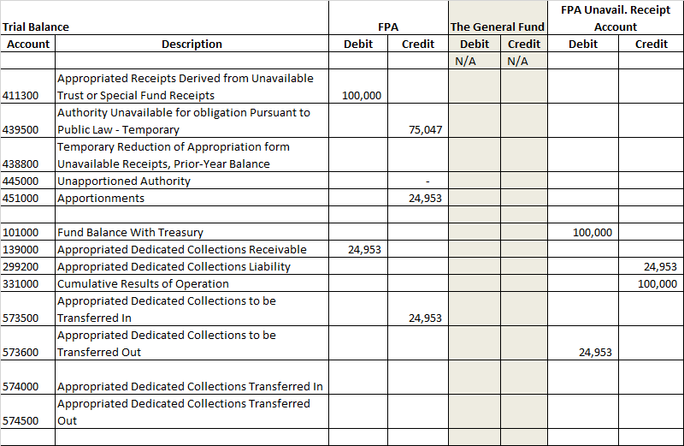
Note, the receipt account had a beginning balance of FBWT and Cumulative Results of Operation of $100,000. No statements are illustrated in this scenario for period 03.

QTR 2 Situation 2 Period 04

The CR passed in Quarter 1 has expired and the agency has received notification that the CR has been extended for an additional 30 days. The amount available for obligation under the extension is $8,408. The annualized level of the appropriation provided under the CR is unchanged.

To adjust the authority temporarily unavailable and associated accounts receivable.
QTR 2 | FPA (F 1XX) |  | FPA Receipt Account (F1X1)
 | Debit | Credit | Debit | Credit | TC
Budgetary Entry  439500 Authority Unavailable Pursuant to Public  445000 Unapportioned Authority  Proprietary Entry  139000 (F) Appropriated Dedicated Collections Receivable  573500 (F) Appropriated Dedicated Collections to be Transferred In  573600 (F) Appropriated Dedicated Collections to be Transferred Out  299200 (F) Appropriated Dedicated Collections Liability | 8,408  8,408 | 8,408  8,408 | 8,408 | 8,408 | A128  A184  A556
General Fund of the U.S. Government (099) | With FPA |  | With FPA Receipt Account
Budgetary Entry  None  Proprietary Entry  None | N/A | N/A | N/A | N/A

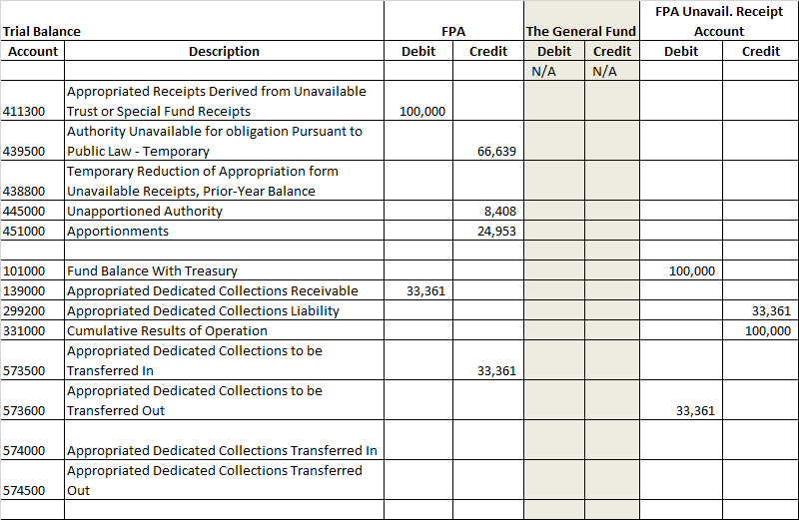
Note, the receipt account had a beginning balance of FBWT and Cumulative Results of Operation of $100,000. No statements are illustrated in this scenario for period 04.

QTR 2 Period 06 (Situation 2)
1A & B To record enactment of the appropriation via the approval and processing of the appropriation warrant by Treasury. Note there is a 1,000 temporary reduction.

1A. To record the enactment of the appropriation via the approval and processing of the appropriation warrant by Treasury.
QTR 2 | FPA (F 1XX) |  | FPA Unavailable Receipt Account (F1X1)
 | Debit | Credit | Debit | Credit | TC
Budgetary Entry  439500 Authority Unavailable Pursuant to Public  445000 Unapportioned Authority  Proprietary Entry  None | 66,639 | 66,639 |  |  | A128R
General Fund of the U.S. Government (099) | With FPA |  | With FPA Unavailable Receipt Account
Budgetary Entry  None  Proprietary Entry  None | N/A | N/A | N/A | N/A

1B Record the approval and processing of the appropriation warrant by Treasury.
QTR 2 | FPA (F 1XX) |  | FPA Unavailable Receipt Account (F1X1)
 | Debit | Credit | Debit | Credit | TC
Budgetary Entry  None  Proprietary Entry  573500 (F) Appropriated Dedicated Collections to be Transferred In  (RC 07)  139000 (F) Appropriated Dedicated Collections Receivable  (RC 27)  101000 (G) Fund Balance With Treasury (RC 40)  574000 (F) Appropriated Dedicated Collections Transferred In  (RC 07)  299200 (F) Appropriated Dedicated Collections Liability (RC 27)  573600 (F) Appropriated Dedicated Collections to be Transferred Out (RC 07)  574500 (F) Appropriated Dedicated Collections Transferred Out (RC 40)  101000 (G) Fund Balance With Treasury (RC 40) | 33,361  100,000 | 33,361  100,000 | 33,361  100,000 | 33,361  100,000 | A184R  A184  A556R  A183
General Fund of the U.S. Government (099) | With FPA |  | With FPA Unavailable Receipt Account
Budgetary Entry  None  Proprietary Entry  201000 (F) Liability for Fund Balance With Treasury (RC 40)  201000 (F) Liability for Fund Balance With Treasury (RC 40) |  | 100,000 | 100,000

1C To record a temporary reduction of unobligated balance derived from special fund receipts.

QTR 1 | FPA (F 1XX) |  | FPA Unavailable Receipt Account (F1X1)
 | Debit | Credit | Debit | Credit | TC
Budgetary Entry  445000 Unapportioned Authority  438800 Temporary Reduction of Appropriation from  Unavailable Receipts, Prior-Year Balance  Proprietary Entry  574500 (F) Appropriated Dedicated Collections Transferred Out (RC 07)  101000 (G) Fund Balance With Treasury (RC 40)  101000 (G) Fund Balance With Treasury  574000 (F) Appropriated Dedicated Collections Transferred In (RC 07) | 1,000  1,000 | 1,000  1,000 | 1,000 | 1,000 | A189  A185
General Fund of the U.S. Government (099) | With FPA |  | With FPA Unavailable Receipt Account
Budgetary Entry  None  Proprietary Entry  201000 (F) Liability for Fund Balance With Treasury (RC 40)  201000 (F) Liability for Fund Balance With Treasury (RC 40) | 1,000 |  |  | 1,000

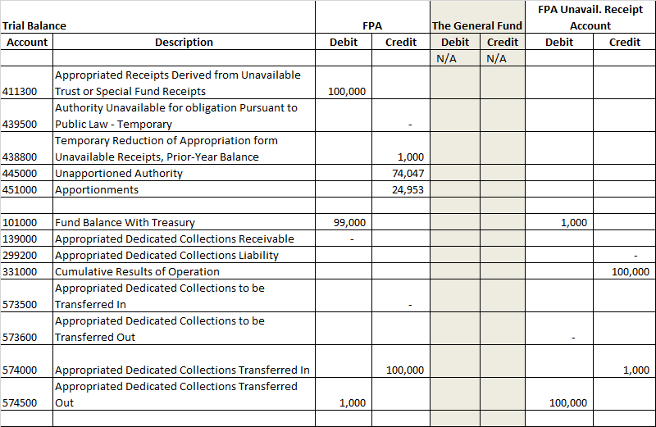

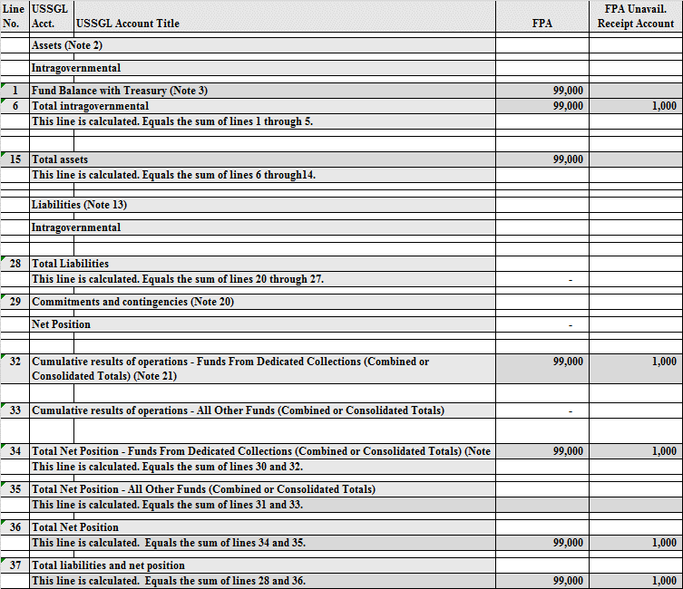
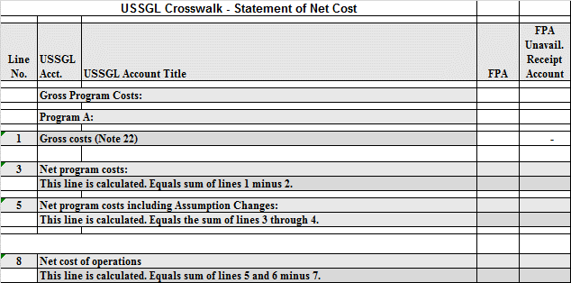

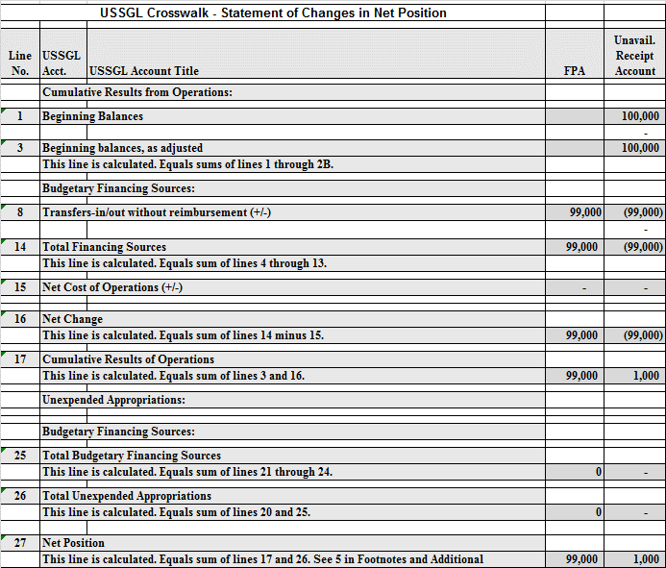
 | STATEMENT OF BUDGETARY RESOURCES
 |  | FPA | Unavail. Receipt Account
Line No. | Budgetary resources:
1290 | Appropriations (discretionary and mandatory) (411300, 438800) | 99,000 | N/A
1910 | Total budgetary resources (calc.) | 99,000
 | Status of budgetary resources:
2204 | Apportioned, unexpired account (451000) | 24,953
2404 | Unapportioned, unexpired accounts (445000) | 74,047
2412 | Unexpired unobligated balance, end of year (calc.) | 99,000
2490 | Unobligated balance, end of year (total) | 99,000
2500 | Total budgetary resources (calc.) | 99,000
 | Outlays, net:
4190 | Outlays, net (total) (discretionary and mandatory) (calc.) | 0
4210 | Agency outlays, net (discretionary and mandatory) | 0

SF 133 AND SCHEDULE P: REPORT ON BUDGET EXECUTION AND BUDGETARY RESOURCES AND BUDGET PROGRAM AND FINANCING SCHEDULE
 |  | FPA |  | Unavail. Receipt Account
Line No. | Budgetary Resources | SF 133 | Schedule P | SF 133 | Schedule P
0900 | Total new obligations, unexpired accounts (490200) |  | 0 | N/A | N/A
 | Budget authority:
 | Appropriations:
 | Discretionary:
1101 | Appropriation (411300) | 100,000 | 100,000
 | Adjustments:
1133 | Unobligated balance of appropriations temporarily reduced (-) (438800) | 1,000 | 1,000
1160 | Appropriation, discretionary (total) (calc.) | 99,000 | 99,000
1900 | Budget authority (total) (calc.) | 99,000 | 99,000
1910 | Total budgetary resources (calc.) | 99,000 | 99,000
 | Memorandum (non-add) entries:
1941 | Unexpired unobligated balance, end of year (445000, 451000) |  | 99,000
 | STATUS OF BUDGETARY RESOURCES
 | Unobligated balance:
 | Apportioned, unexpired accounts:
2201 | Available in current period (451000) | 24,953
2403 | Other (445000) | 74,047
2412 | Unexpired unobligated balance: end of year (calc) | 99,000
2490 | Unobligated balance, end of year (total) (calc.) | 99,000 | -
2500 | Total Budgetary resources (cacl.) | 99,000
 | Memorandum (non-add) entries:
2501 | Subject to apportionment – excluding anticipated amounts (44500, 451000) | 99,000 | -
2503 | Direct unobligated balance, end of year – excluding anticipated amounts (445000, 451000) | 99,000
 | CHANGE IN OBLIGATED BALANCE
 | Unpaid obligations:
3010 | New obligations, unexpired accounts (490200) | 4,000 | 4,000
3020 | Outlays (gross) (-) (490200) | (4,000) | (4,000)
 | BUDGET AUTHORITY AND OUTLAYS, NET
 | Discretionary:
 | Gross budget authority and outlays:
4000 | Budget authority, gross (calc.) | 99,000 | 99,000
4010 | Outlays from new discretionary authority (490200) | 0 | 0
4020 | Outlays, gross (total) (calc.) | 0 | 0
4070 | Budget authority, net (discretionary) (calc.) | 99,000 | 99,000
4080 | Outlays, net (discretionary) (calc.) | 0 | 0
4180 | Budget authority, net (total) | 99,000 | 99,000
4190 | Outlays, net (total) | 99,000 | 99,000

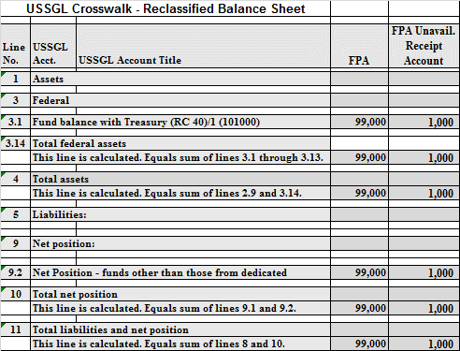
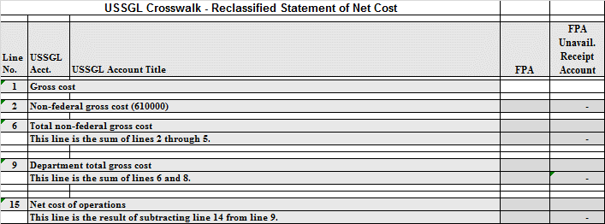
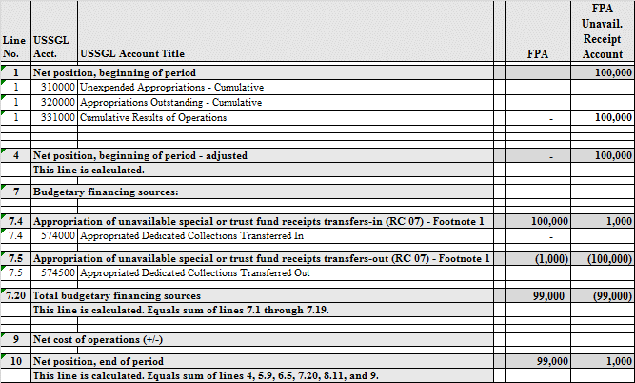

OMB Bulletin No. 18-05 (Apportionment of the Continuing Resolution(s) for Fiscal Year 2019,) See also current OMB Circular No. A-11 Section 123, “Apportionments under a Continuing Resolution.”
Treasury Financial Manual, Part 2, Chapter 2000, Section 2030.2
Account 109000, Fund Balance With Treasury under a Continuing Resolution, must be zero at year-end.

